# Generated QA Summary

--- Entry for custom_id: d5bbc7c80dba11ecb1e81171463288e9 ---

Image Source 1 -

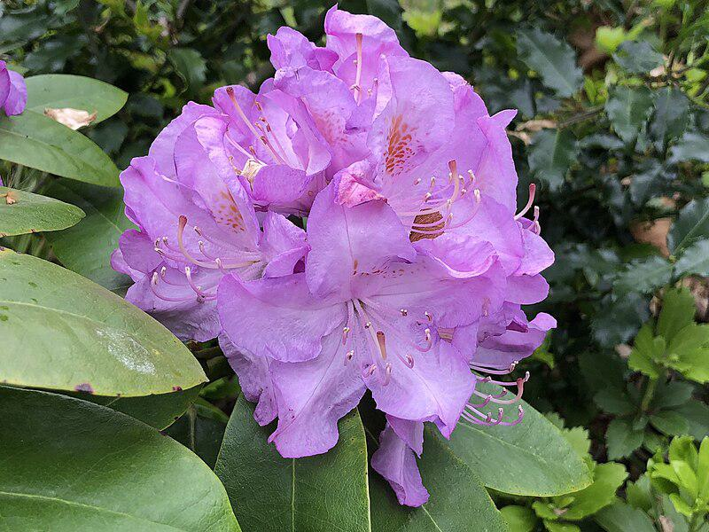

Caption for image source 1: 2020-05-08 15 17 05 Minnetonka Rhododendron flower along Tranquility Court in the Franklin Farm section of Oak Hill, Fairfax County, Virginia Minnetonka Rhododendron flower along Tranquility Court in the Franklin Farm section of Oak Hill, Fairfax County, Virginia.

Example Question - "Does a Minnetonka Rhododendron flower have petals in a cup shape?"

Example Answer - "No, a Minnetonka Rhododendron flower does not have petals in a cup shape."

Additional Text Source 1 - Rhododendron macrophyllum, the Pacific rhododendron, California rosebay, California rhododendron, coast rhododendron or big leaf rhododendron, is a large-leaved species of Rhododendron native to the Pacific Coast of North America. It is the state flower of Washington. (from: Rhododendron macrophyllum)

Generated Question - Is the Minnetonka Rhododendron flower native to the Pacific Coast of North America like the Pacific rhododendron?

Generated Answer - No, the Minnetonka Rhododendron is found in Virginia, not native to the Pacific Coast.

--- Entry for custom_id: d5bbc8720dba11ecb1e81171463288e9 ---

Image Source 1 -

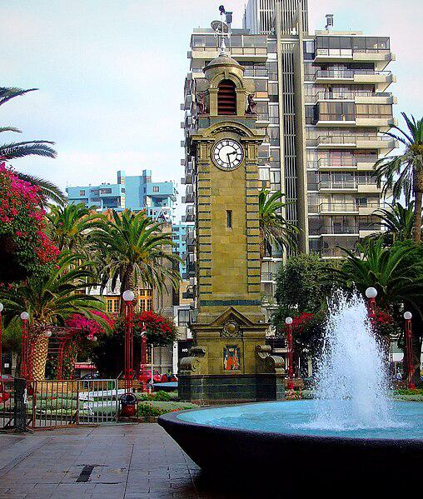

Caption for image source 1: Torre del Reloj de la Plaza Colón de Antofagasta (1).

Example Question - "What water-related object is sitting in front of the Torre del Reloj?"

Example Answer - "A fountain is sitting in front of the Torre del Reloj."

Additional Text Source 1 - The Torre del Puerco (36.331186°N 6.161276°W﻿ / 36.331186; -6.161276) dates to the 16th century, but later was used as a defensive post during the Battle of Barrosa in 1811. The Torre Bermeja (36.374989°N 6.191318°W﻿ / 36.374989; -6.191318) is a defensive tower located on the Playa de la Barrosa. (from: Chiclana de la Frontera)

Generated Question - Are the Torre del Reloj and the Torre Bermeja both used as defensive structures?

Generated Answer - No, only the Torre Bermeja is a defensive tower; the Torre del Reloj is a clock tower.

--- Entry for custom_id: d5bbc8cc0dba11ecb1e81171463288e9 ---

Image Source 1 -

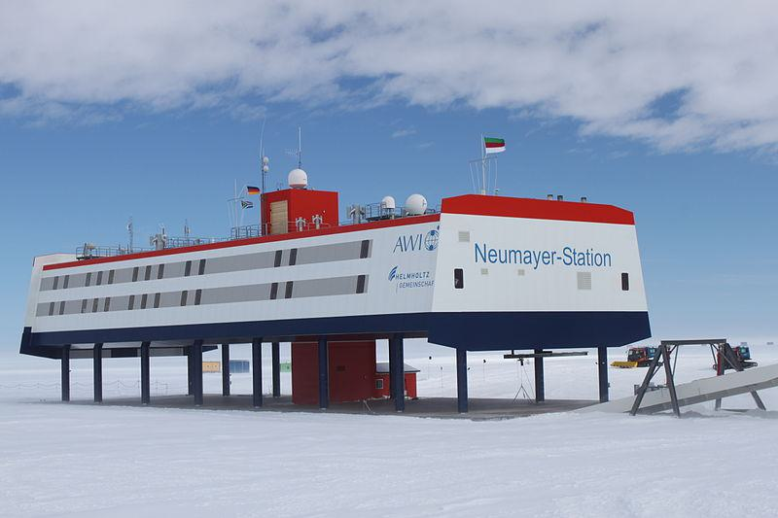

Caption for image source 1: Neumayer Station Antarctica 2009-12 5 German Antarctic research base Neumayer III, located in Dronning Maud Land, Antarctica, operated by the Alfred Wegener Institute (AWI), Helmholtz Centre for Polar and Marine Research.

Image Source 2 -



Caption for image source 2: Neumayer Station Antarctica 2009-12 2 German Antarctic research base Neumayer Station III, located in Dronning Maud Land, Antarctica, operated by the Alfred Wegener Institute Helmholtz Centre for Polar and Marine Research (AWI).

Example Question - "How many ground floor entrances are there to the Neumayer station in Antarctica?"

Example Answer - "There is one ground floor entrance to the Neumayer station in Antarctica."

Additional Text Source 1 - The first all-female over-wintering group is from Germany and spends the 1990-1991 winter at Georg von Neumayer, with the first German female station leader and medical doctor Monika Puskeppeleit. In 1991 In-Young Ahn is the first female leader of an Asian research station (King Sejong Station), and the first South Korean woman to step onto Antarctica. (from: Women in Antarctica)

Generated Question - Did the German all-female over-wintering group at Georg von Neumayer station precede the current Neumayer III station shown in the images?

Generated Answer - Yes, the all-female group stayed at the earlier Georg von Neumayer station before Neumayer III was built.

--- Entry for custom_id: d5bbc91c0dba11ecb1e81171463288e9 ---

Image Source 1 -

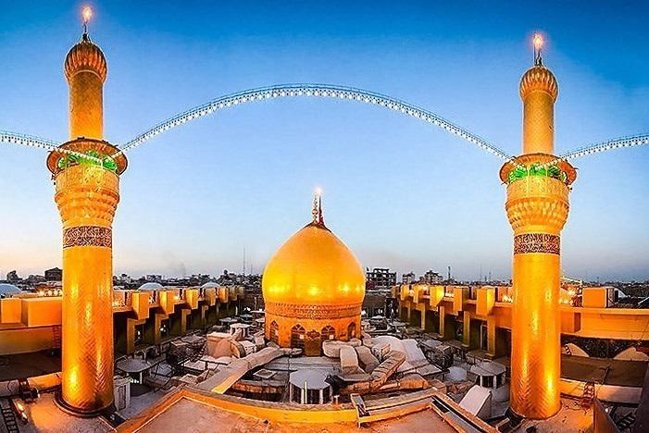

Caption for image source 1: Imam Husayn Shrine by Tasnimnews 01 Ashura Mourning in Karabala, Iraq.

Image Source 2 -

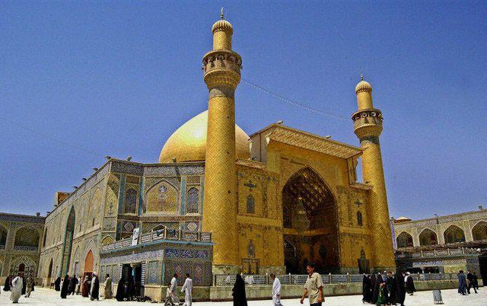

Caption for image source 2: Imam Ali Shrine (1) Imam Ali Shrine.

Example Question - "What color are both domes on the Imam Husayn Shrine and the Imam Ali Shrine?"

Example Answer - "Gold is the color used in both domes of the Imam Husayn Shrine and the Imam Ali Shrine."

Additional Text Source 1 - In the Islamic tradition, In Shia Islam, after the first four sites, the Imam Ali Mosque in Najaf and the Imam Husayn Shrine in Karbala, Fatimah Masumeh Shrine in Qom are the holiest sites. For Sufi Muslims, after the first four sites, Mazar Ghous in Baghdad, Iraq, is the holiest site, followed by Data Darbar in Lahore, Pakistan. (from: Holiest sites in Islam)

Generated Question - Are the Imam Husayn Shrine and Imam Ali Shrine both considered among the holiest sites in Shia Islam?

Generated Answer - Yes, both shrines are among the holiest sites in Shia Islam.

--- Entry for custom_id: d5bbc9760dba11ecb1e81171463288e9 ---

Image Source 1 -

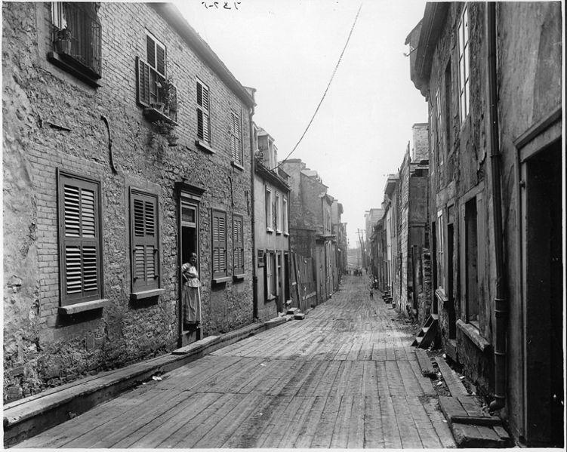

Caption for image source 1: Little Champlain Street, Quebec City, QC, 1916 Little Champlain Street, Quebec City, 1916.

Image Source 2 -

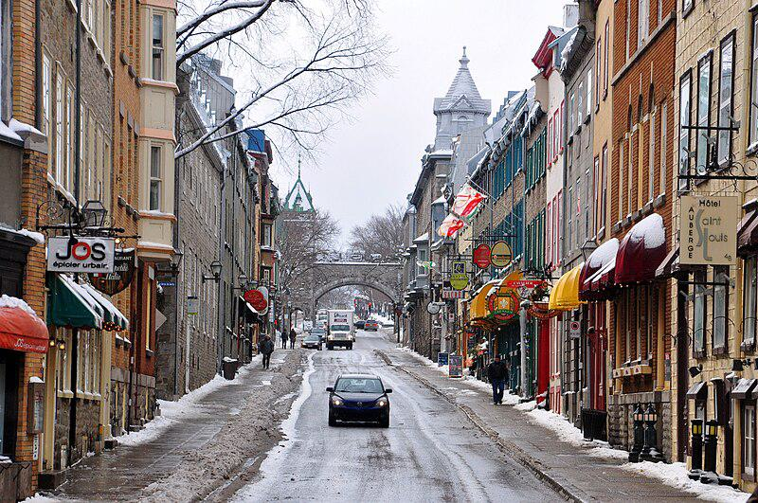

Caption for image source 2: Quebec City Rue St-Louis 2010b Quebec City Rue Saint-Louis winter 2010 Upper Town. 57-63 St. Louis Street - a National Historic Site of Canada.

Example Question - "Which street was paved with boards; Little Champlain Street, Quebec City, 1916 or Quebec City Rue Saint-Louis winter 2010?"

Example Answer - "Little Champlain Street, Quebec City, 1916 was a street paved with boards."

Additional Text Source 1 - Saint-Vallier Est Street, previously called Saint-Charles Street, the first paved road in Quebec. A funicular car allows for easy transportation up Cap Diamant connecting to Upper Town from the narrow Petit-Champlain road at the foot of the Cape to the top with a marvellous view of the city. (from: Old Quebec)

Generated Question - Considering the paving materials and transportation methods, which street likely had easier access to Upper Town, Little Champlain Street in 1916 or Saint-Vallier Est Street?

Generated Answer - Saint-Vallier Est Street likely had easier access due to the funicular car connecting to Upper Town.

--- Entry for custom_id: d5bbca160dba11ecb1e81171463288e9 ---

Image Source 1 -

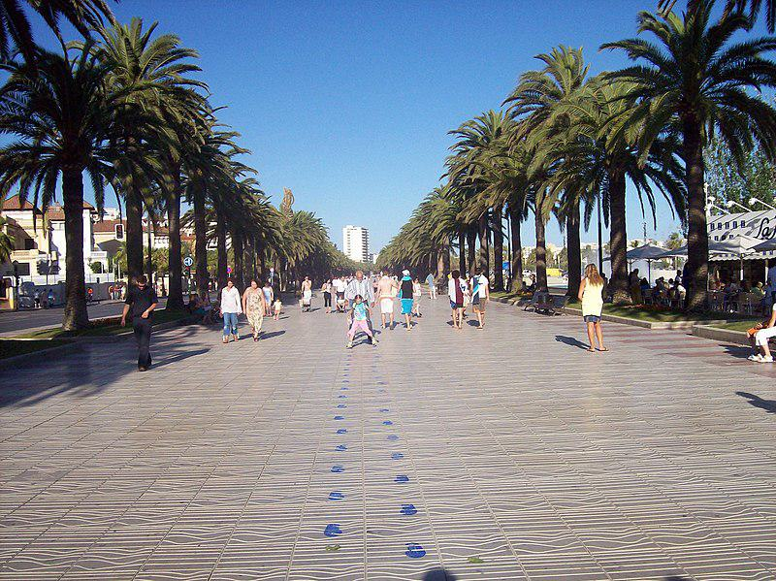

Caption for image source 1: Salou boulevard.

Example Question - "What shapes are painted down the center of Salou Boulevard?"

Example Answer - "Blue footprints are painted down the center of Salou Boulevard."

Additional Text Source 1 - They took turns in singing each other's repertoire. During a vacation in Salou, Spain in the same year he became infected with the "Mexican Flu". (from: Thomas Berge)

Generated Question - Could the people walking on Salou Boulevard be affected by the "Mexican Flu" mentioned in the additional text?

Generated Answer - Yes, since the people are on Salou Boulevard where the "Mexican Flu" infection occurred.

--- Entry for custom_id: d5bbca840dba11ecb1e81171463288e9 ---

Image Source 1 -

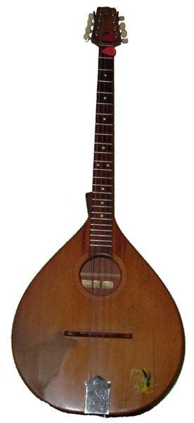

Caption for image source 1: Irish Bouzouki.

Image Source 2 -

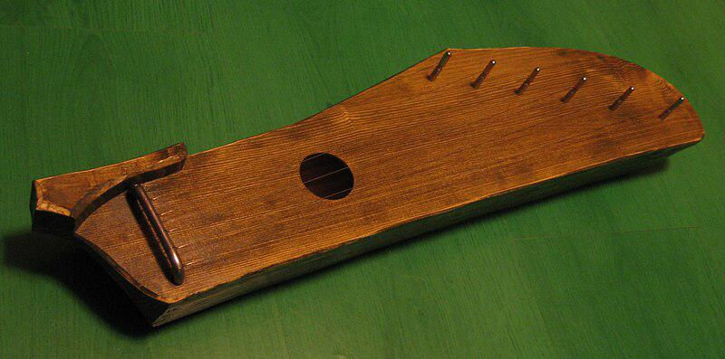

Caption for image source 2: Väikekannel Estonian 6-stringed kannel made by Rait Pihlap in 2008..

Example Question - "Does a Estonian 6-stringed kannel and an Irish Bouzouki have the same number of strings?"

Example Answer - "An Estonian 6-stringed kannel and an Irish Bouzouki do not have the same number of strings."

Additional Text Source 1 - Luthier Stefan Sobell, who coined the term "cittern" for his modern, mandolin-based instruments, originally used the term for short scale instruments irrespective of the number of their strings, but he now applies "cittern" to all five course instruments irrespective of scale length, and "octave mandolin" to all four course instruments, leaving out bouzouki entirely. (from: Irish bouzouki)

Generated Question - Based on the string courses, would a luthier classify an Irish Bouzouki and an Estonian 6-stringed kannel the same way?

Generated Answer - No, a luthier classifies them differently due to their string courses and instrument types.

--- Entry for custom_id: d5bbcb1a0dba11ecb1e81171463288e9 ---

Image Source 1 -

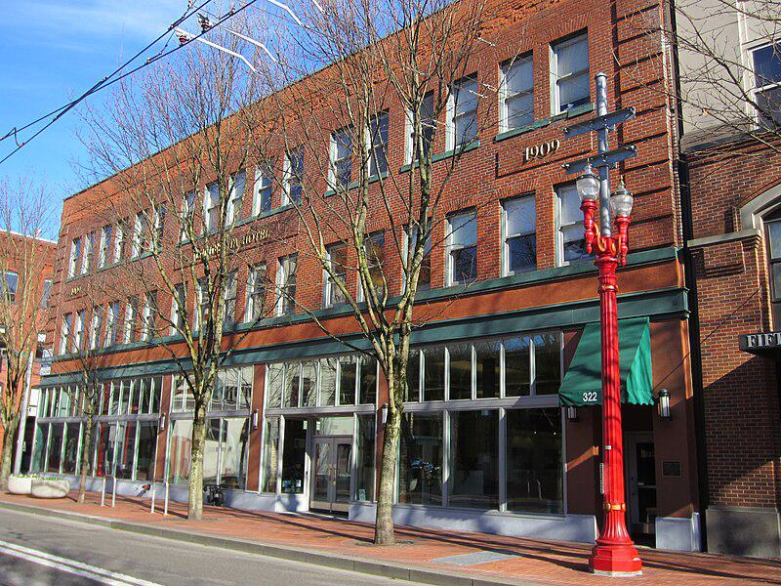

Caption for image source 1: Minnesota Hotel, Portland, OR 2012 Minnesota Hotel in northwest Portland, Oregon in 2012.

Example Question - "How many floors is the Minnesota Hotel in Portland Oregon?"

Example Answer - "There are three floors at the Minnesota Hotel in Portland, Oregon."

Additional Text Source 1 - Many other historical dance halls have sprung hard wood floors, such as the Spanish Ballroom at Glen Echo Park, Maryland (1933), Willowbrook Ballroom in Chicago (1921), the Crystal Ballroom in Portland, Oregon (1914), and the Carrillo Ballroom in Santa Barbara, California (1914). (from: Sprung floor)

Generated Question - Does the Minnesota Hotel in Portland, Oregon likely have a sprung hardwood dance floor like the Crystal Ballroom in Portland?

Generated Answer - The Minnesota Hotel likely does not have a sprung hardwood dance floor like the Crystal Ballroom.

--- Entry for custom_id: d5bbcb740dba11ecb1e81171463288e9 ---

Image Source 1 -

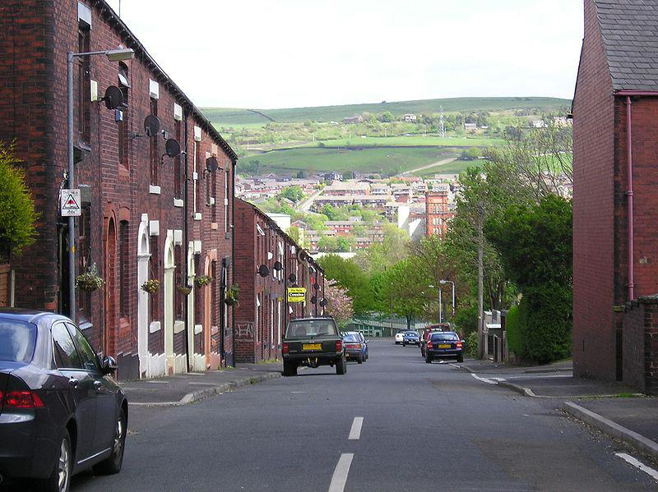

Caption for image source 1: Alfred street - Shaw and Crompton.

Example Question - "Do most people affix their satellite on the roof of the building or on the front of the building along Alfred street - Shaw and Crompton in Greater Manchester, England?"

Example Answer - "Most people affix their satellite on the front of the building along Alfred street at Shaw and Crompton."

Additional Text Source 1 - The town entered the national media in 2010, 2011 and 2012; for the kidnapping of Sahil Saeed, the mugging and death of Nellie Geraghty (which featured on Crimewatch), and the explosion of a house in Buckley Street respectively. Shaw and Crompton Metrolink station opened as part of Greater Manchester's light-rail Metrolink network on 16 December 2012. (from: Shaw and Crompton)

Generated Question - Considering the events in Shaw and Crompton and the opening of its Metrolink station, how might the street view of Alfred Street reflect changes in community safety or accessibility?

Generated Answer - The street view likely shows a stable residential area with improved accessibility due to the Metrolink station, despite past safety incidents.

--- Entry for custom_id: d5bbcbc40dba11ecb1e81171463288e9 ---

Image Source 1 -

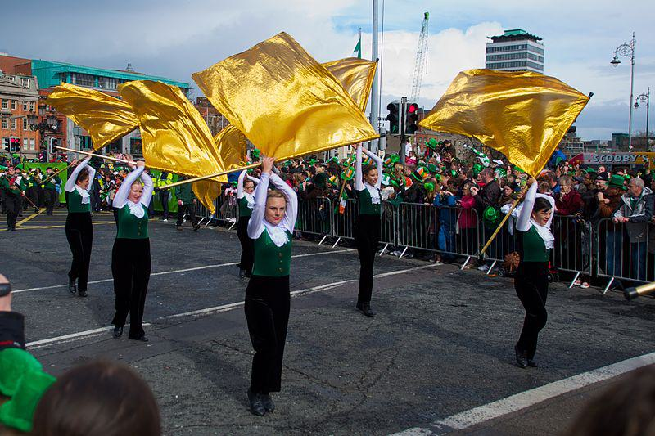

Caption for image source 1: St. Patricks Festival, Dublin (6844451604).

Example Question - "How many dancers participate in the golden flag dance in St.Patricks Festival Dublin?"

Example Answer - "Six dancers participate in the golden flag dance in St. Patrick's Festival in Dublin."

Additional Text Source 1 - Leonor Orosa-Goquingco also had native elements in her dances like Noli Dance Suite and Filipinescas: Philippine Life, Legend and Lore in Dance, which had mixed ballet and folk dances into one performance. Due to this trend, many other writers and dancers continued to connect this Western dance style with native influences, motifs, and even history. (from: Philippine dance)

--- Entry for custom_id: d5bbcc140dba11ecb1e81171463288e9 ---

Image Source 1 -

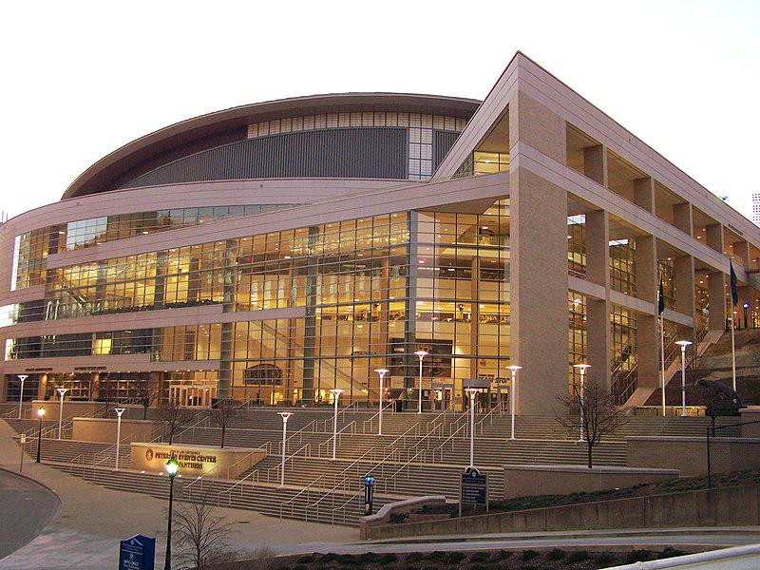

Caption for image source 1: PetersenEventsCenter at Pitt.

Example Question - "Is the central structure of the Petersen Events Center rounded or straight-edged?"

Example Answer - "The central structure of the Petersen Events Center is rounded."

Additional Text Source 1 - The Pittsburgh Panthers men's basketball team is the NCAA Division I intercollegiate men's basketball program of the University of Pittsburgh, often referred to as "Pitt", located in Pittsburgh, Pennsylvania. The Pitt men's basketball team competes in the Atlantic Coast Conference (ACC) and plays their home games in the Petersen Events Center. (from: Pittsburgh Panthers men's basketball)

Generated Question - Does the Petersen Events Center serve as the home venue for the University of Pittsburgh's men's basketball team?

Generated Answer - Yes, the Petersen Events Center is the home venue for the University of Pittsburgh's men's basketball team.

--- Entry for custom_id: d5bbcc5a0dba11ecb1e81171463288e9 ---

Image Source 1 -

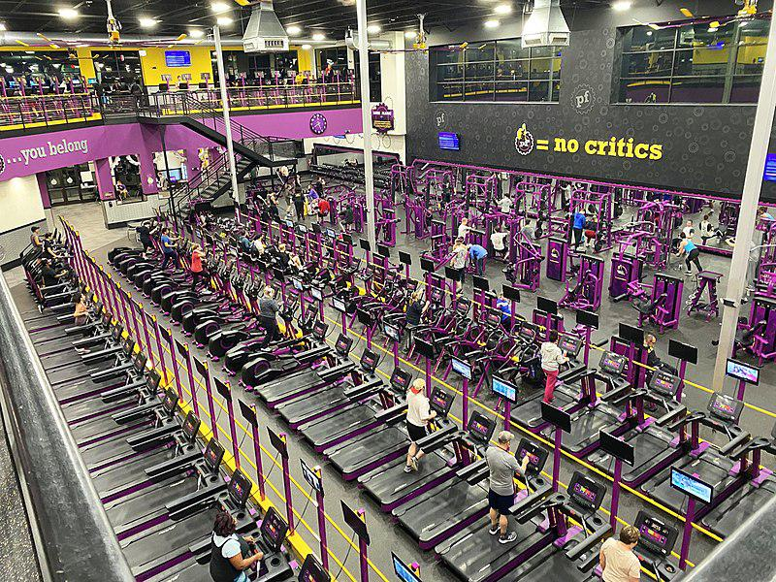

Caption for image source 1: Planet Fitness Cincinnati Planet Fitness in Cincinnati, Ohio.

Image Source 2 -

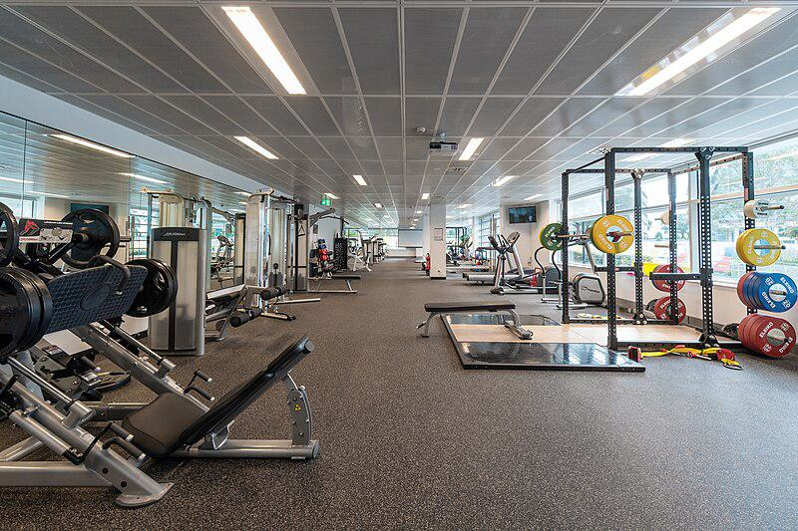

Caption for image source 2: ACPE-Campus Gym ACPE Gym.

Example Question - "Which has a wider selection of cardio equipment; Planet Fitness in Cincinnati, or ACPE-Campus Gym?"

Example Answer - "Planet Fitness has a wider selection of cardio equipment compared to the ACPE-Campus gym."

Additional Text Source 1 - The Department of Campus Recreation sponsors a wide variety of intramural sports, club sports, and recreation activities such as group fitness classes, aquatic programs, gym and fitness programs, special events, and outdoor recreation activities and trips. The Greek community at SIUE has 19 fraternities and sororities and four governing councils with a tradition of campus leadership and community involvement. (from: Southern Illinois University Edwardsville)

Generated Question - Which gym likely offers more group fitness classes and recreational activities, Planet Fitness Cincinnati or ACPE-Campus Gym?

Generated Answer - ACPE-Campus Gym likely offers more group fitness classes and recreational activities due to its campus recreation sponsorship.

--- Entry for custom_id: d5bbccb40dba11ecb1e81171463288e9 ---

Image Source 1 -

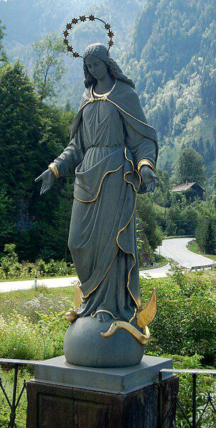

Caption for image source 1: Töpperbrücke, Virgin Mary statue The statue of Vergin Mary on the Topperbrucke in Kasten / Lunz am See, Lower Austria. The statue, originally created 1855 from Mariazeller Eisenguss, got lost during a thunderstorm in summer 1861 when the whole bridge was destroyed, and was replaced by this statue cast in Blansko, Moravia..

Example Question - "How many stars are on the halo worn by the Virgin Mary in The statue of Vergin Mary on the Töpperbrücke in Kasten / Lunz am See, Lower Austria?"

Example Answer - "On the statue of Virgin Mary on the Töpperbrücke in Kasten, she is wearing 11 stars are on the halo."

Additional Text Source 1 - The months of May and October are traditionally "Marian months" for Roman Catholics; the daily Rosary is encouraged in October and in May Marian devotions take place in many regions. Popes have issued a number of Marian encyclicals and Apostolic Letters to encourage devotions to and the veneration of the Virgin Mary. (from: Mary, mother of Jesus)

Generated Question - Considering the Marian devotions in May and October, how might the Virgin Mary statue on the Töpperbrücke inspire local religious practices?

Generated Answer - The statue likely inspires Marian devotions and Rosary prayers during May and October.

--- Entry for custom_id: d5bbcdfe0dba11ecb1e81171463288e9 ---

Image Source 1 -

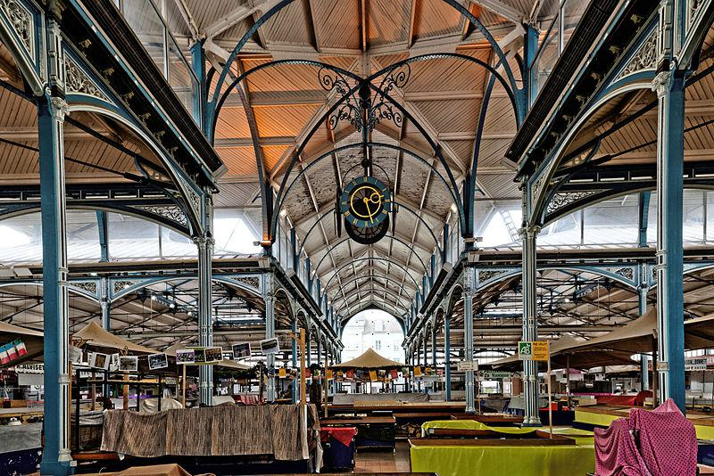

Caption for image source 1: Dijon Halles intérieur 02.

Example Question - "On what is the Clock in ceiling of Dijon Halles intérieur hung on?"

Example Answer - "The clock on the ceiling of Dijon Halles intérieur is hung on a black railing structure."

Additional Text Source 1 - Unlike many Roman numeral clock dials, which show the "4" position as IIII, the Great Clock faces depict "4" as IV. The clock's gun metal hour hands and copper minute hands are 8.75 feet (2.7 m) and 14 feet (4.3 m) long respectively. (from: Big Ben)

Generated Question - Is the clock in Dijon Halles intérieur more similar in style to Big Ben's clock in terms of numeral representation and hand size?

Generated Answer - The Dijon Halles clock likely uses Roman numerals like Big Ben, but Big Ben's hands are notably large and detailed.

--- Entry for custom_id: d5bbce580dba11ecb1e81171463288e9 ---

Image Source 1 -

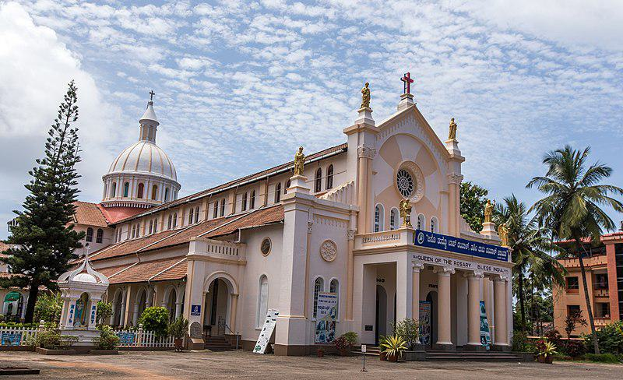

Caption for image source 1: Rosario Cathedral.

Example Question - "What color are the statues at the top of the facade of Rosario Cathedral?"

Example Answer - "The facades atop the cathedral are gold."

Additional Text Source 1 - The Propylaeum can be accessed from the pedestrian passage called Pasaje Juramento ("Oath Passage"), which starts at Buenos Aires St. between the municipal building (Palacio de los Leones) and the Cathedral, in front of Plaza 25 de Mayo (May 25 Square). Statues flank the passage by famous sculptor Lola Mora. (from: Rosario, Santa Fe)

Generated Question - Are the golden statues on top of Rosario Cathedral similar to the statues flanking the Pasaje Juramento in Rosario?

Generated Answer - No, the statues on Rosario Cathedral are gold, while the statues flanking Pasaje Juramento are by sculptor Lola Mora and not described as gold.

--- Entry for custom_id: d5bbceb20dba11ecb1e81171463288e9 ---

Image Source 1 -

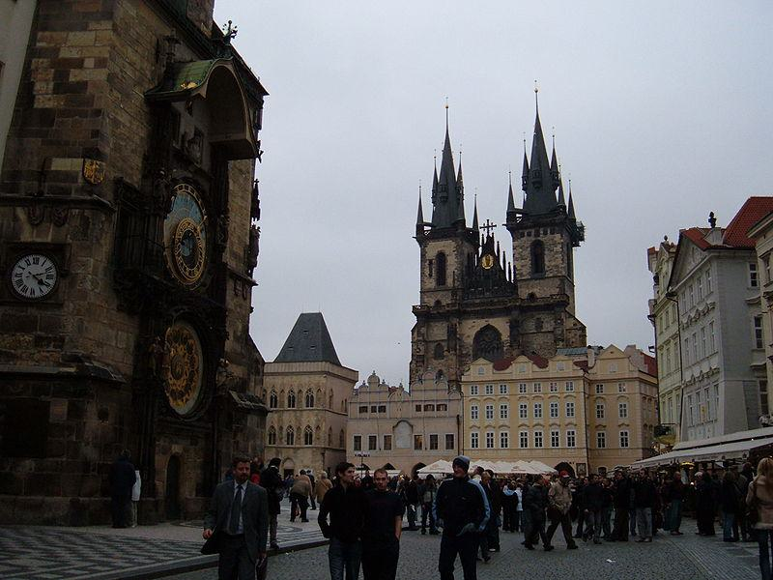

Caption for image source 1: In Old Town Square, Prague 4.

Example Question - "What type of numbers are on the clock face in the Old Town Square in Prague?"

Example Answer - "There are Roman numerals on the clock face in the Old Town Square in Prague."

Additional Text Source 1 - The Old Town of Vilnius (Lithuanian: Vilniaus senamiestis, Polish: Stare Miasto w Wilnie, Belarusian: Стары горад у Вільнюсе, Russian: Старый город в Вильнюсe), one of the largest surviving medieval old towns in Northern Europe, has an area of 3.59 square kilometres (887 acres). (from: Vilnius Old Town)

Generated Question - Is the Old Town Square in Prague larger or smaller than the Old Town of Vilnius based on their described areas?

Generated Answer - The Old Town Square in Prague is smaller since the Old Town of Vilnius covers 3.59 square kilometers.

--- Entry for custom_id: d5bbcf020dba11ecb1e81171463288e9 ---

Image Source 1 -

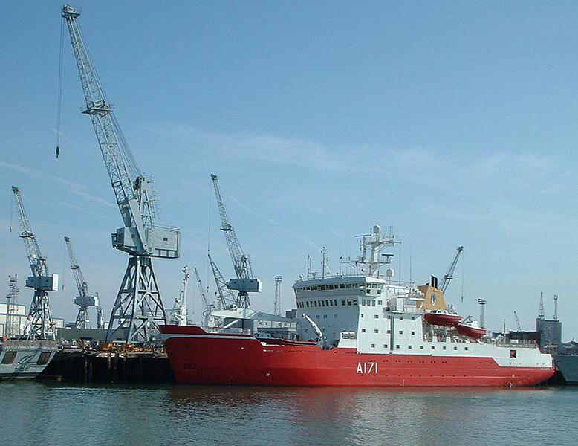

Caption for image source 1: HMS Endurance, Portsmouth HMS Endurance is an Antarctic patrol ship, a 1A1 icebreaker..

Example Question - "What is printed on the side of the HMS Endurance?"

Example Answer - "A171 is printed on the side of the HMS Endurance."

Additional Text Source 1 - They found that the entire port side of the Endurance had been driven inwards and compressed, and the ice had entirely filled the bow and stern sections. The ship's Blue Ensign was hoisted up her mizzen mast so that she would, in Shackleton's word's, "go down with colours flying." (from: Endurance (1912 ship))

Generated Question - Does the damage described in the additional text source suggest the HMS Endurance could still float with its bow and stern filled with ice?

Generated Answer - No, the bow and stern filled with ice and compressed port side suggest the ship could not float.

--- Entry for custom_id: d5bbcf480dba11ecb1e81171463288e9 ---

Image Source 1 -

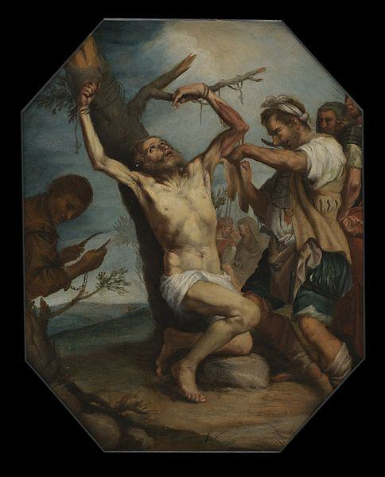

Caption for image source 1: Martyrdom of Saint Bartholomew, 17th century Wellcome L0075250.

Example Question - "On Jusep de Ribera's painting "Martyrdom of St. Bartholomew," which arm of St. Bartholomew is being cut?"

Example Answer - "St. Bartholomew's left arm is being cut on "Martyrdom of St. Bartholomew" by Jusep de Ribera."

Additional Text Source 1 - The Martyrdom of Saint Bartholomew (1634) by Jusepe de Ribera depicts Bartholomew's final moments before being flayed alive. The viewer is meant to empathize with Bartholomew, whose body seemingly bursts through the surface of the canvas, and whose outstretched arms embrace a mystical light that illuminates his flesh. (from: Bartholomew the Apostle)

Generated Question - How does Jusepe de Ribera emphasize Saint Bartholomew's suffering in the painting "Martyrdom of Saint Bartholomew"?

Generated Answer - Ribera emphasizes Bartholomew's suffering by showing his contorted body and outstretched arms embracing light.

--- Entry for custom_id: d5bbcfa20dba11ecb1e81171463288e9 ---

Image Source 1 -

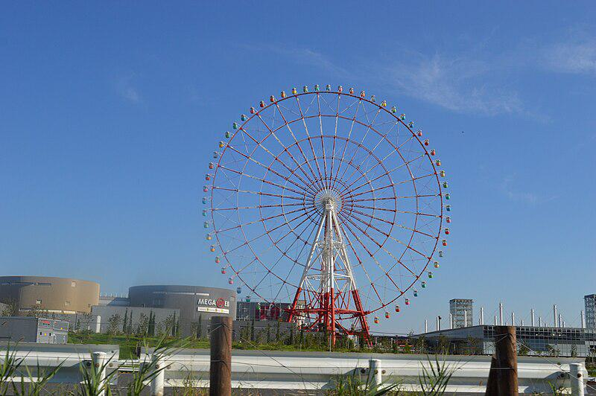

Caption for image source 1: Palette Town Daikanransha Daikanransha ("Big Ferris Wheel") at Palette Town in Odaiba, Tokyo, Japan.

Image Source 2 -

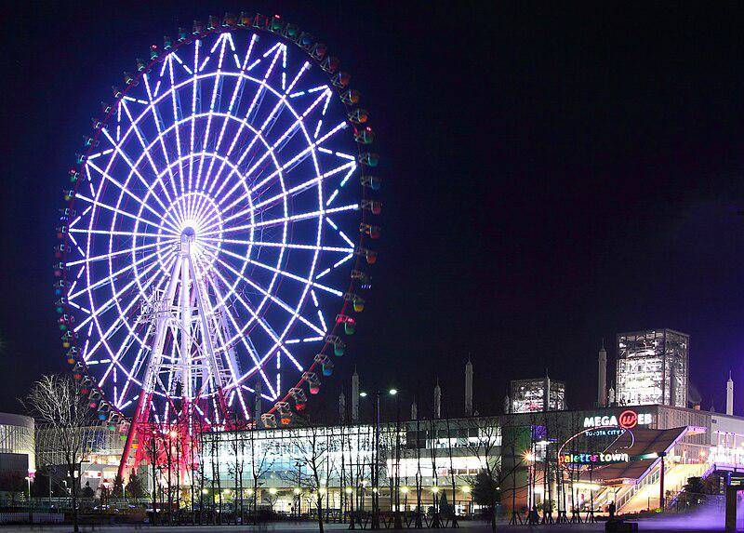

Caption for image source 2: Palette Town Ⅱ.

Example Question - "Does the Big Ferris Wheel at Palette Town in Tokyo light up at night?"

Example Answer - "Yes, the Big Ferris Wheel at Palette Town in Tokyo lights up at night."

Additional Text Source 1 - Many important facilities are located in Aomi, such as the Miraikan scientific museum, Oedo-Onsen-Monogatari (Sentō), the Palette Town (including VenusFort shopping mall, the 115-metre (377 ft) Daikanransha Ferris wheel, Zepp Tokyo music hall, Megaweb - the exhibition hall of Toyota), a National Institute of Technology. (from: Aomi)

Generated Question - Is the Daikanransha Ferris wheel at Palette Town in Tokyo taller than 100 meters and does it illuminate at night?

Generated Answer - Yes, the Daikanransha Ferris wheel is 115 meters tall and lights up at night.

--- Entry for custom_id: d5bbcff20dba11ecb1e81171463288e9 ---

Image Source 1 -

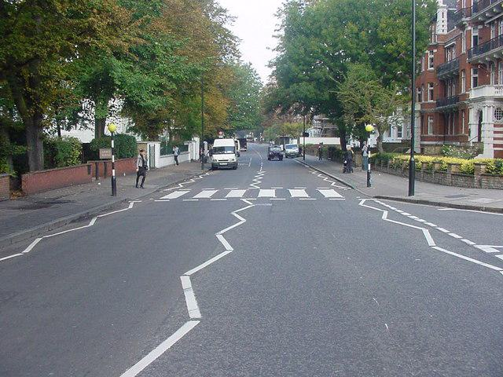

Caption for image source 1: Abbey Road - geograph.org.uk - 916869 Abbey Road The crosswalk (zebra crossing) where the Beatles Album photo was taken. To those having authority...please get rid of all the extra markings that were not there when the Beatles photograph was taken..

Example Question - "What shape is the white line in the center of Abby Road?"

Example Answer - "The white line is in a zig zag shape."

Additional Text Source 1 - She is intended to serve as the centerpiece of a museum dedicated to the history of Atlantic steam, the White Star Line, and its most famous ship, Titanic. (from: White Star Line)

Generated Question - Is the Abbey Road crosswalk's zigzag line design similar to the intended centerpiece of the Titanic museum's theme?

Generated Answer - No, Abbey Road's zigzag lines are unrelated to the Titanic museum's steamship theme.

--- Entry for custom_id: d5bbd04c0dba11ecb1e81171463288e9 ---

Image Source 1 -

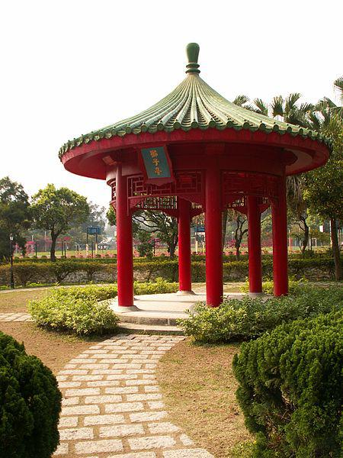

Caption for image source 1: CUHKRoundPavilion.

Image Source 2 -

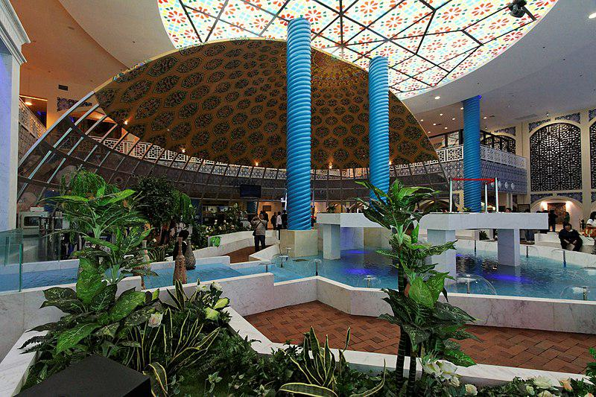

Caption for image source 2: Iran Pavilion, inside.

Example Question - "What grows both near the "Lion Pavilion" in the Chinese University of Hong Kong and in the Iran Pavilion?"

Example Answer - "Bushes grow both near the "Lion Pavilion" in the Chinese University of Hong Kong and in the Iran Pavilion."

Additional Text Source 1 - As Chinese law prohibit foreign institutions, including those in Hong Kong, to independently establish educational institutions in the country, CUHK had to find a Chinese partner for the establishment of the new university via the regulation of "Chinese-Foreign Cooperation in Running Schools", (from: Chinese University of Hong Kong, Shenzhen)

Generated Question - Considering the Chinese law on foreign institutions, how might the presence of the Lion Pavilion at CUHK reflect cultural integration compared to the Iran Pavilion's design?

Generated Answer - The Lion Pavilion at CUHK reflects Chinese cultural integration, while the Iran Pavilion showcases distinct Iranian architectural style.

--- Entry for custom_id: d5bbd0920dba11ecb1e81171463288e9 ---

Image Source 1 -

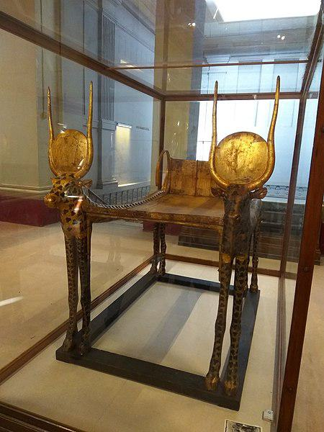

Caption for image source 1: Egyptian museum inside (February, 2017) 4.

Example Question - "On what is Tutankhamun's golden bed resting?"

Example Answer - "Tutankhamun's golden bed is resting on the floor."

Additional Text Source 1 - Certain cartouches where a king's name should appear have been altered, as if to reuse the property of a previous pharaoh—has often occurred. However, this instance may simply be the product of "updating" the artifacts to reflect the shift from Tutankhaten to Tutankhamun. (from: Tomb of Tutankhamun)

Generated Question - Was Tutankhamun's golden bed likely reused or updated based on the alteration of king's names on artifacts?

Generated Answer - Yes, the bed was likely updated or reused, reflecting the shift from Tutankhaten to Tutankhamun.

--- Entry for custom_id: d5bbd0e20dba11ecb1e81171463288e9 ---

Image Source 1 -

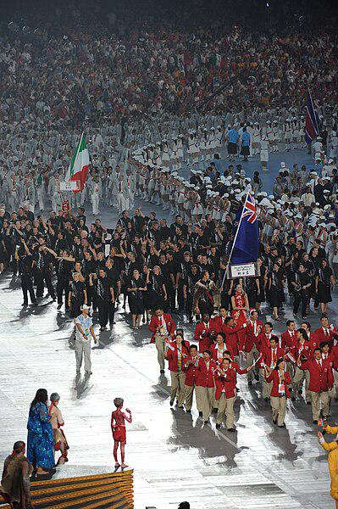

Caption for image source 1: 2008 Summer Olympics - Opening Ceremony - Beijing, China 同一个世界 同一个梦想 - U.S. Army World Class Athlete Program - FMWRC (4928955398).

Example Question - "The 2008 Summer Olympics had some participants in black attires?"

Example Answer - "Yes, during the 2008 Summer Olympics some participants wore black attire."

Additional Text Source 1 - The showpiece of the 2008 Summer Olympics was the Beijing National Stadium, nicknamed "The Bird's Nest" because of its nest-like skeletal structure. (from: 2008 Summer Olympics)

Generated Question - Did the participants in the 2008 Summer Olympics opening ceremony march inside the Bird's Nest stadium?

Generated Answer - Yes, the participants marched inside the Beijing National Stadium, known as the Bird's Nest.

--- Entry for custom_id: d5bbd13c0dba11ecb1e81171463288e9 ---

Image Source 1 -

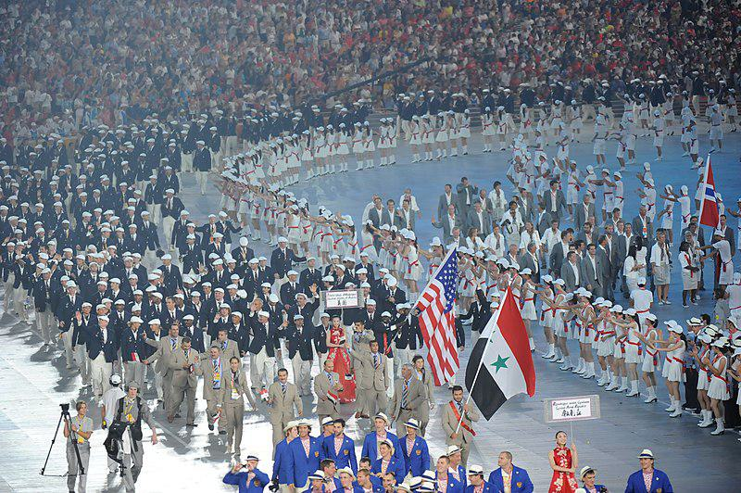

Caption for image source 1: 2008 Summer Olympics - Opening Ceremony - Beijing, China 同一个世界 同一个梦想 - U.S. Army World Class Athlete Program - FMWRC (4928870644).

Example Question - "What color hat did American athletes wear while walking in the 2008 Summer Olympics opening ceremony?"

Example Answer - "The American athletes wore white while walking in the 2008 Summer Olympics opening ceremony."

Additional Text Source 1 - The 2008 Games also set numerous world and Olympics records, and were also the most expensive Summer Olympics of all time and second most expensive overall after the 2014 Winter Games in Sochi. The opening ceremony was lauded by spectators and numerous international presses as spectacular, spellbinding and, by many accounts, "the greatest ever in the history of Olympics". (from: 2008 Summer Olympics)

Generated Question - Did the American athletes wear the same color hats as the athletes in blue suits during the 2008 Summer Olympics opening ceremony?

Generated Answer - No, the American athletes wore white hats, while the athletes in blue suits wore dark hats.

--- Entry for custom_id: d5bbd1820dba11ecb1e81171463288e9 ---

Image Source 1 -

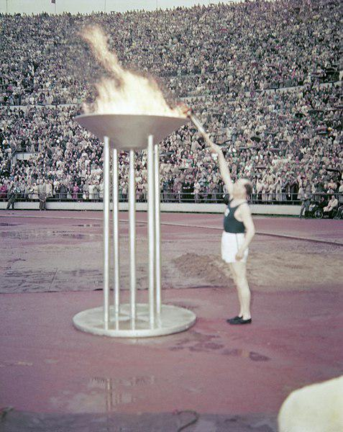

Caption for image source 1: Olympiatuli 1952 Paavo Nurmi lights the fire at the Olympic games in Helsinki 1952.According to the copyright council as the photograph is regarded a photographic image, not a work, and copyright thus has expired..

Example Question - "What shape is the base of the Olympic cauldron that Paavo Nurmi lit at the 1952 Olympics in Helsinki?"

Example Answer - "The base of the Olympic cauldron that Paavo Nurmi lit at the 1952 Olympics in Helsinki is a circle."

Additional Text Source 1 - The first well-known athlete to light the cauldron in the stadium was ninefold Olympic Champion Paavo Nurmi, who excited the home crowd in Helsinki in 1952. In 1968, Enriqueta Basilio became the first woman to light the Olympic Cauldron at the Olympic Games in Mexico City. (from: Olympic flame)

Generated Question - Who was the first woman to light the Olympic cauldron after Paavo Nurmi, and in which year did it happen?

Generated Answer - Enriqueta Basilio was the first woman to light the Olympic cauldron in 1968.

--- Entry for custom_id: d5bbd1dc0dba11ecb1e81171463288e9 ---

Image Source 1 -

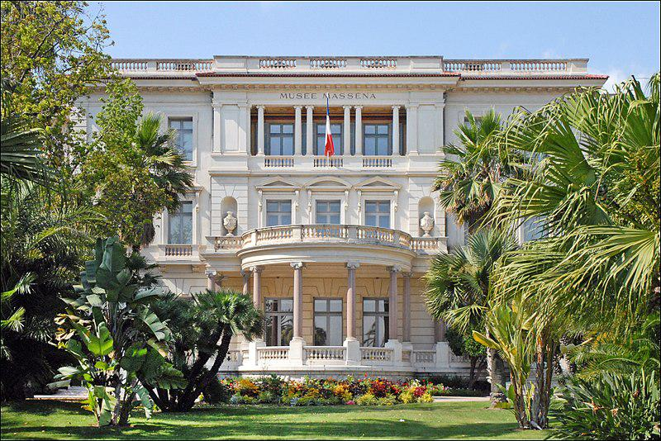

Caption for image source 1: Le musée Masséna (Nice) (5953504945).

Example Question - "What's located in front of the columns by the south facade of the Masséna museum?"

Example Answer - "A flower bed is located in front of the columns."

Additional Text Source 1 - The Door of Saint Cristopher or De la Lonja (1887–1895) of the south transept, was designed by Adolfo Fernandez Casanova and completed in 1917; it was originally designed by the architect Demetrio de los Rios in 1866. A replica of the "Giraldillo" stands in front of its gate. (from: Seville Cathedral)

Generated Question - Are there any statues or replicas visible in front of the south facade of the Masséna museum similar to the "Giraldillo" replica at Seville Cathedral?

Generated Answer - No, only plants and a flower bed are visible in front of the Masséna museum's south facade.

--- Entry for custom_id: d5bbd22c0dba11ecb1e81171463288e9 ---

Image Source 1 -



Caption for image source 1: NNC-US-1908-G$10-Indian Head (motto) 1908 G$10 Indian Head (motto)Gold (fineness 0.9000), 27mm, 16.718g, designed by Augustus Saint-GaudensJN2015-6760-61.

Image Source 2 -



Caption for image source 2: NNC-US-1860-1C-Indian Head Cent (wreath & shield) 1860-1C-Indian Head Cent (wreath & shield)JN2015-6840-41.

Example Question - "What words are not on the 1860 1C Indian Head Cent but are on 1908G $10 Indian Head?"

Example Answer - "The words "In God We Trust" are not on the 1860 1C Indian Head Cent but are on 1908G $10 Indian Head."

Additional Text Source 1 - While the 1–5 cent denominations were issued almost continuously the 10-cent coils were only issued twice, once as a yellow Washington-head stamp first issued in 1908, (See: Coil stamps Table-1) and once as a 10-cent yellow Franklin-head coil that wasn't issued until 1916. (See: Coil stamps Table-2) (from: Washington–Franklin Issues)

Generated Question - Are the 1908 $10 Indian Head coin and the 1860 1-cent Indian Head coin both part of the Washington–Franklin Issues series?

Generated Answer - No, the 1908 $10 Indian Head coin is not part of the Washington–Franklin Issues, unlike the 1-cent coil stamps mentioned.

--- Entry for custom_id: d5bbd27c0dba11ecb1e81171463288e9 ---

Image Source 1 -

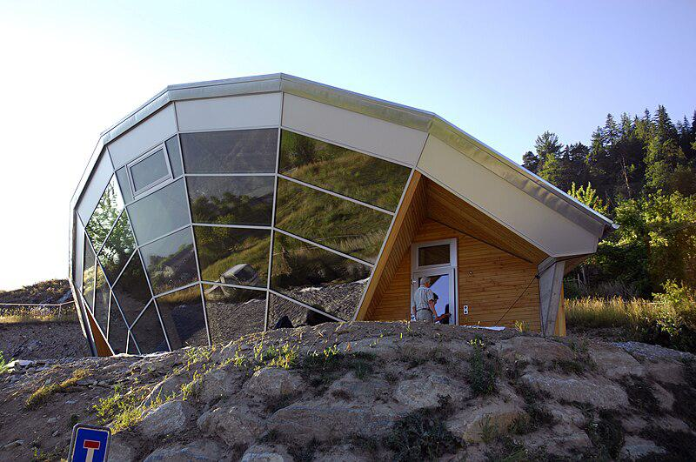

Caption for image source 1: Heliodom erschmatt Switzerland 25.

Example Question - "What kind of material is there on the exterior of the Sonnenhaus Heliodom in Erschmatt Switzerland?"

Example Answer - "The exterior of the Sonnenhaus Heliodom in Erschmatt Switzerland is glass."

Additional Text Source 1 - The entire village of Erschmatt is designated as part of the Inventory of Swiss Heritage Sites. In 2013 Herbert Lötscher built the world's first residential Heliodom or sun house concept. (from: Erschmatt)

Generated Question - Is the Sonnenhaus Heliodom in Erschmatt Switzerland located in a heritage site village and does it have a glass exterior?

Generated Answer - Yes, it is in a heritage site village and has a glass exterior.

--- Entry for custom_id: d5bbd2cc0dba11ecb1e81171463288e9 ---

Image Source 1 -

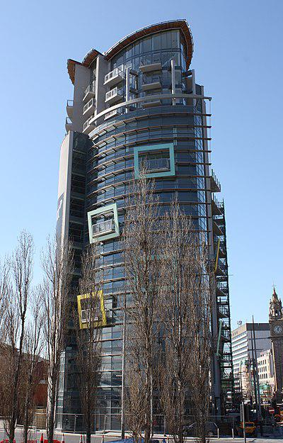

Caption for image source 1: The Boat, Belfast, April 2010 (06) The Boat, Queen's Square, Belfast, Northern Ireland, April 2010.

Image Source 2 -

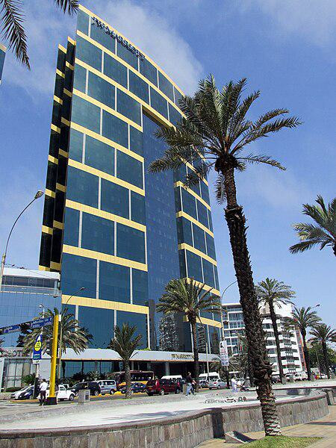

Caption for image source 2: Lima Peru Modern Highrise Skyscraper Modern highrise skyscraper in Lima..

Example Question - "Do the The Boat, Queen's Square, Belfast, Northern Ireland and the Modern highrise skyscraper in Lima both have colored borders around some of the windows?"

Example Answer - "Yes, both The Boat, Queen's Square, Belfast, Northern Ireland and the Modern highrise skyscraper in Lima have colored borders surrounding some of their windows."

Additional Text Source 1 - In its 2018 report on Best Places to Live in Britain, The Sunday Times named Ballyhackamore, "the brunch capital of Belfast", as the best place in Northern Ireland. The district of Ballyhackamore has even acquired the name "Ballysnackamore" due to the preponderance of dining establishments in the area. (from: Belfast)

Generated Question - Considering the dining reputation of Ballyhackamore in Belfast, is The Boat building located near this popular food district?

Generated Answer - Yes, The Boat is in Queen's Square, Belfast, near Ballyhackamore, known for its dining scene.

--- Entry for custom_id: d5bbd36c0dba11ecb1e81171463288e9 ---

Image Source 1 -

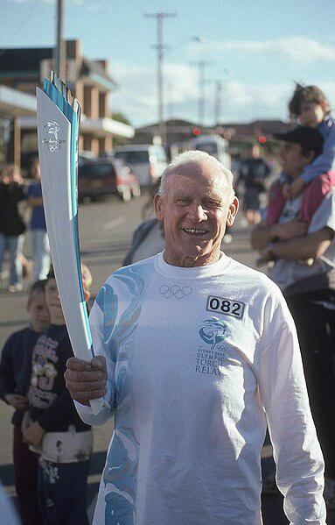

Caption for image source 1: Torch bearer Fred Atkins takes the torch through Taree, NSW on its way to Sydney..

Example Question - "What number did Fred Atkins wear while transporting the Olympic Torch?"

Example Answer - "Fred Atkins wore the number 082 while transporting the Olympic Torch."

Additional Text Source 1 - The design of the 2008 Olympic Torch was based on traditional scrolls and used a traditional Chinese design known as the "Propitious Clouds" (祥云). The torch was designed to remain lit in 65 km/h (40 mph) winds, and in rain of up to 50 mm (2 in) per hour. (from: 2008 Summer Olympics)

Generated Question - Did the 2008 Olympic Torch carried by Fred Atkins have a design inspired by traditional Chinese elements and was it weather-resistant?

Generated Answer - Yes, it was inspired by traditional Chinese scrolls and designed to stay lit in strong wind and rain.

--- Entry for custom_id: d5bbd4160dba11ecb1e81171463288e9 ---

Image Source 1 -

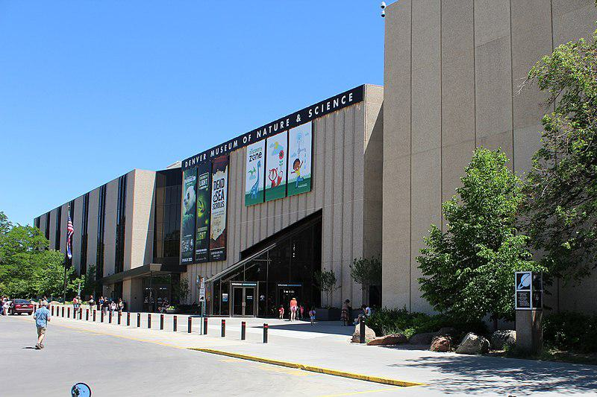

Caption for image source 1: Denver Museum of Nature and Science View from north west Denver Museum of Nature and Science. View from north-west..

Image Source 2 -

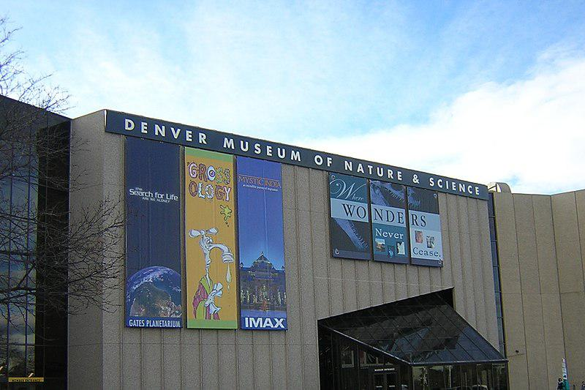

Caption for image source 2: Denver Museum of Nature & Science.

Example Question - "Does the Denver Museum of Nature & Science sometimes change the promotional banners displayed on the front of the building?"

Example Answer - "Yes, the Denver Museum of Nature & Science sometimes changes the promotional banners displayed on the front of the building."

Additional Text Source 1 - Works from both his Soviet and American years were included. Items were lent to the exhibition from the Moscow Kremlin Museums, the Museum "Samotsvety" (Moscow), the Russian State Precious Metals and Gems Repository (Moscow), the Denver Museum of Nature and Science (Colorado, USA), the Kazanjian Foundation and private collectors in the United States. (from: Vasily Konovalenko)

Generated Question - Does the Denver Museum of Nature & Science collaborate internationally for exhibitions based on the banners and text source?

Generated Answer - Yes, it collaborates internationally, lending items from Russian and American sources.

--- Entry for custom_id: d5bbd4700dba11ecb1e81171463288e9 ---

Image Source 1 -



Caption for image source 1: SamTrans 702, Gillig BRT Hybrid on route 130 bus at South San Francisco station, June 2018 (cropped) SamTrans route 130 bus at South San Francisco station in June 2018.

Image Source 2 -



Caption for image source 2: SamTrans bus 458, a Gillig BRT on Route 292, San Francisco International Airport (43777447611).

Example Question - "Are the ads on SamTrans on one or both sides of the bus?"

Example Answer - "The ads are one side of the bus."

Additional Text Source 1 - One year later, SamTrans began operation of mainline bus service to San Francisco. Shuttle service began in 2000.In addition to fixed route bus and paratransit operations, the district participates in the administration of the San Jose-San Francisco commuter rail line Caltrain. (from: SamTrans)

Generated Question - Do both SamTrans buses shown serve routes connecting to San Francisco or its airport?

Generated Answer - Yes, one serves route 130 to South San Francisco, and the other serves route 292 to San Francisco International Airport.

--- Entry for custom_id: d5bbd4c00dba11ecb1e81171463288e9 ---

Image Source 1 -

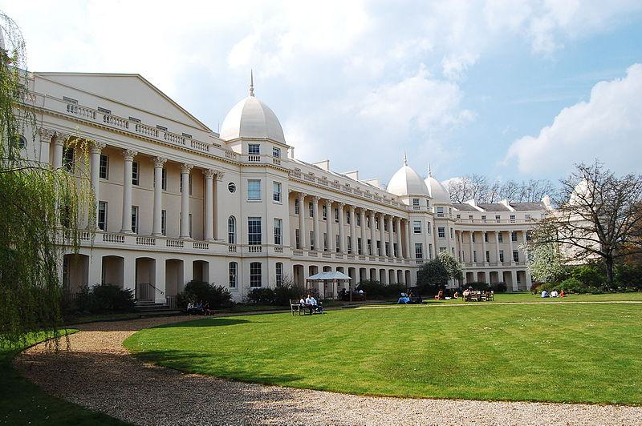

Caption for image source 1: LBS campus 2.

Example Question - "What shape are the roof structures with points mounted on top of them built into at the LBS campus?"

Example Answer - "Domes with points mounted on top of them are built into at the LBS campus."

Additional Text Source 1 - It was generally understood to be the height of the building to the top of its architectural elements including spires, but not including "temporary" structures (such as antennas or flagpoles), which could be added or changed relatively easily without requiring major changes to the building's design. (from: List of tallest buildings and structures)

Generated Question - Are the pointed roof structures at the LBS campus considered permanent architectural elements or temporary structures?

Generated Answer - They are permanent architectural elements, not temporary structures.

--- Entry for custom_id: d5bbd5b00dba11ecb1e81171463288e9 ---

Image Source 1 -

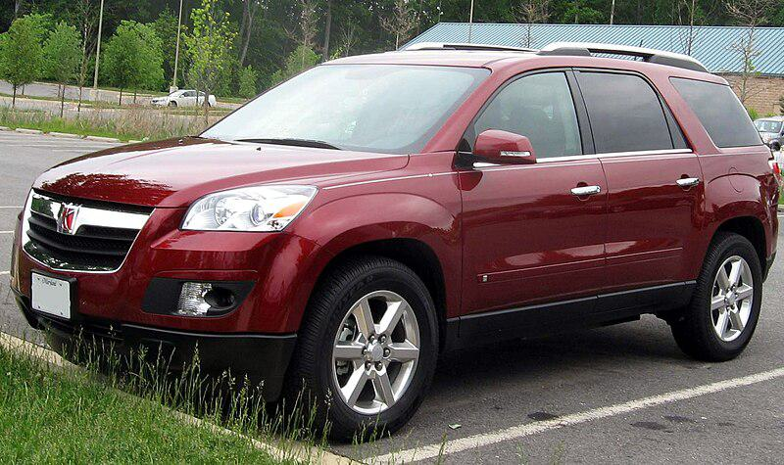

Caption for image source 1: 07-Saturn-Outlook-XR.

Example Question - "How many roof rails does a Saturn Outlook have?"

Example Answer - "The Saturn Outlook has 2 roof rails."

Additional Text Source 1 - In the UK, the Cossack model featured large body decals, roof rails, running boards, 15-in alloy wheels, and on some versions, a sunroof, steel bullbars, spotlights, a rear-mounted spare tyre, and semibucket seats. Other markets' importers made similar upgrades and many were also called Cossack. (from: Lada Niva)

Generated Question - Does the Saturn Outlook shown have the same number of roof rails as the Cossack model described in the text?

Generated Answer - No, the Saturn Outlook has 2 roof rails, while the Cossack model has roof rails but the exact number is not specified.

--- Entry for custom_id: d5bbd61e0dba11ecb1e81171463288e9 ---

Image Source 1 -

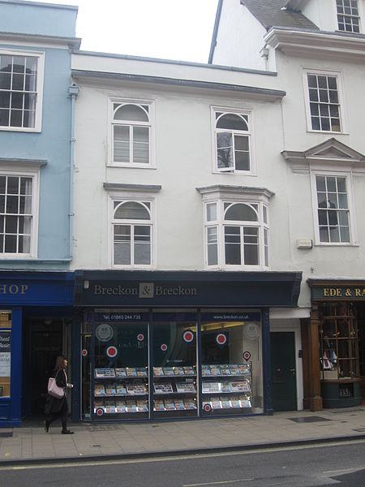

Caption for image source 1: 118 High Street, Oxford 118 High Street, Oxford, England; 16th cent. refronted in 19th cent..

Example Question - "How many windows do not protrude off the facade of 118 High Street in Oxford?"

Example Answer - "There are three windows that don't protrude off the facade of 118 High Street in Oxford."

Additional Text Source 1 - There are many historical buildings on the street, including the University of Oxford buildings and colleges. Locally the street is often known as "The High". (from: High Street, Oxford)

Generated Question - Considering the historical significance of High Street, Oxford, how many windows on 118 High Street protrude from the building facade?

Generated Answer - Two windows protrude from the facade of 118 High Street, Oxford.

--- Entry for custom_id: d5bbd6640dba11ecb1e81171463288e9 ---

Image Source 1 -

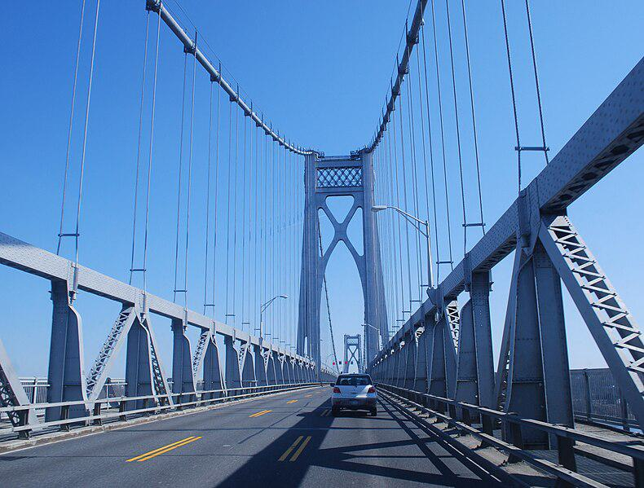

Caption for image source 1: Mid-Hudson Bridge 2010-03-07 The Mid-Hudson Bridge, spanning the Hudson River between Poughkeepsie and Highland..

Example Question - "Are there sidewalks on both sides of the Mid-Hudson Bridge?"

Example Answer - "Yes, there are sidewalks on both sides of the Mid-Hudson Bridge."

Additional Text Source 1 - Major bridges in the city include the Walkway over the Hudson, a former railroad bridge called the Poughkeepsie Bridge which reopened as a public walkway on October 3, 2009; and the Mid-Hudson Bridge, a major thoroughfare built in 1930 that carries U.S. Route 44 over the Hudson. The city of Poughkeepsie lies in New York's 18th congressional district. (from: Poughkeepsie, New York)

Generated Question - Does the Mid-Hudson Bridge carry a major U.S. route and have pedestrian access like the Walkway over the Hudson?

Generated Answer - The Mid-Hudson Bridge carries U.S. Route 44 and has sidewalks, while the Walkway over the Hudson is a pedestrian-only bridge.

--- Entry for custom_id: d5bbd6b40dba11ecb1e81171463288e9 ---

Image Source 1 -

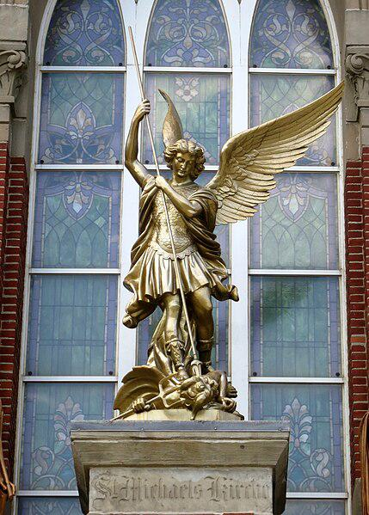

Caption for image source 1: Saint Michael Church (Fort Loramie, Ohio) - St. Michael the Archangel statue Saint Michael Church (Fort Loramie, Ohio) - St. Michael the Archangel statue.

Example Question - "What weapon is the devil holding in St. Michael the Archangel statue (at Saint Michael Church, Fort Loramie, Ohio)?"

Example Answer - "A trident is the weapon held by the devil in St. Michael the Archangel statue at Saint Michael Church, Fort Loramie, Ohio."

Additional Text Source 1 - While in the Serbian Orthodox Church Saint Sava has a special role as the establisher of its autocephaly and the largest Belgrade church is devoted to him, the capital Belgrade's Orthodox cathedral, the see church of the patriarch, is devoted to Archangel Michael (in Serbian: Арханђел Михаило / Arhanđel Mihailo). (from: Michael (archangel))

Generated Question - Which figure is more prominently honored in the Serbian Orthodox Church's main cathedral compared to Saint Michael Church in Ohio?

Generated Answer - Archangel Michael is honored in the Serbian Orthodox Church's main cathedral, while Saint Michael Church in Ohio honors St. Michael the Archangel.

--- Entry for custom_id: d5bbd7040dba11ecb1e81171463288e9 ---

Image Source 1 -

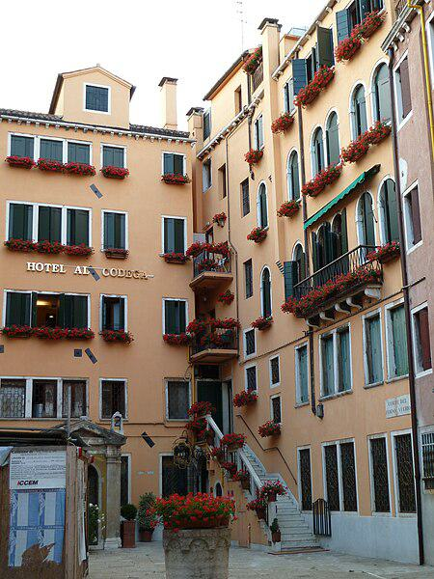

Caption for image source 1: Hotel al codega san marco venezia.

Example Question - "What color flowers were displayed outside of the Hotel al codega san marco venezia in June of 2011?"

Example Answer - "There were red flowers outside the hotel."

Generated Question - Are the windows of Hotel al codega san marco venezia mostly rectangular or arched in shape?

Generated Answer - The windows are mostly rectangular with some arched ones on the right side.

--- Entry for custom_id: d5bbd7540dba11ecb1e81171463288e9 ---

Image Source 1 -

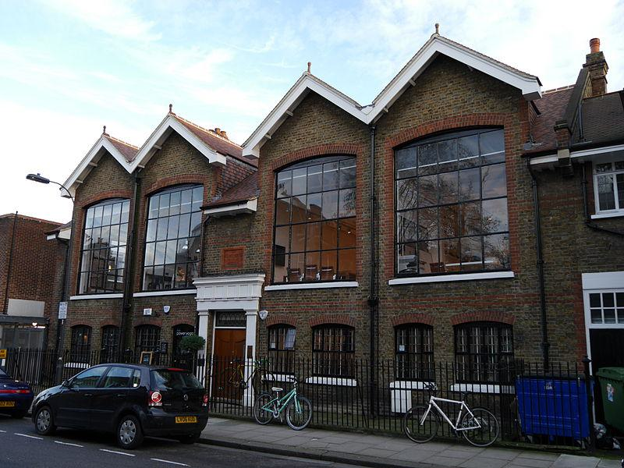

Caption for image source 1: The Glass House, Fulham 05 The Glass House, Fulham.

Example Question - "Is the fence in front of The Glass House in Fulham taller or shorter than a bicycle?"

Example Answer - "The fence in font of the building is taller than a typical bicycle."

Additional Text Source 1 - Craven Cottage is known by several affectionate nicknames from fans, including: The (River) Cottage, The Fortress (or Fortress Fulham), Thameside, The Friendly Confines, SW6, Lord of the Banks, The House of Hope, The Pavilion of Perfection, The 'True' Fulham Palace and The Palatial Home. (from: Craven Cottage)

Generated Question - Is the building called The Glass House in Fulham likely related to the nicknamed Craven Cottage known as The River Cottage?

Generated Answer - No, The Glass House and Craven Cottage are different buildings with distinct names and nicknames.

--- Entry for custom_id: d5bbd7a40dba11ecb1e81171463288e9 ---

Image Source 1 -



Caption for image source 1: Amanita bisporigera 17932.

Image Source 2 -



Caption for image source 2: Funnel chanterelles mushrooms Image title: Funnel chanterelles mushrooms Image from Public domain images website, http://www.public-domain-image.com/full-image/flora-plants-public-domain-images-pictures/fungi-mushrooms-public-domain-images-pictures/funnel-chanterelles-mushrooms.jpg.html.

Example Question - "Is the amanita bisporigera mushroom larger or smaller than funnel chanterelles mushrooms?"

Example Answer - "Amanita bisporigera mushrooms are larger than funnel chanterelles mushrooms."

Additional Text Source 1 - Of the most lethal mushrooms, five—the death cap (A. phalloides), the three destroying angels (A. virosa, A. bisporigera, and A. ocreata), and the fool's mushroom (A. verna)—belong to the genus Amanita, and two more—the deadly webcap (C. rubellus), and the fool's webcap (C. orellanus)—are from the genus Cortinarius. (from: Mushroom poisoning)

Generated Question - Are any of the Amanita genus mushrooms shown in the images considered among the most lethal mushrooms?

Generated Answer - Yes, Amanita bisporigera is one of the most lethal mushrooms.

--- Entry for custom_id: d5bbd7f40dba11ecb1e81171463288e9 ---

Image Source 1 -

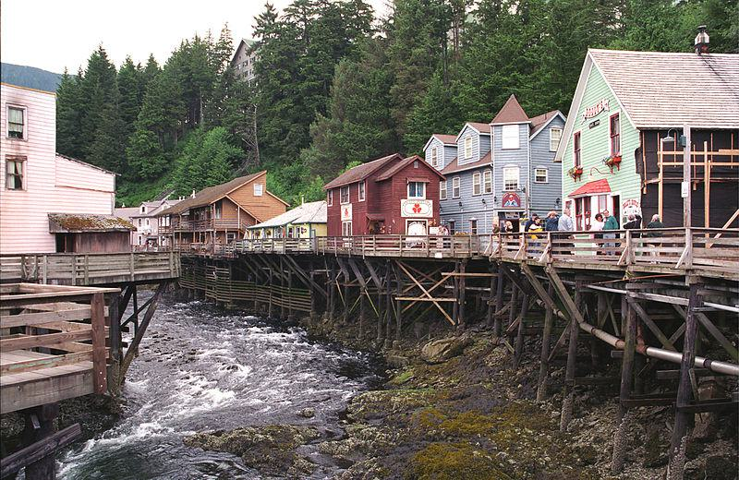

Caption for image source 1: Creek Street(js)01 Creek Street, Ketchikan (Alaska).

Image Source 2 -

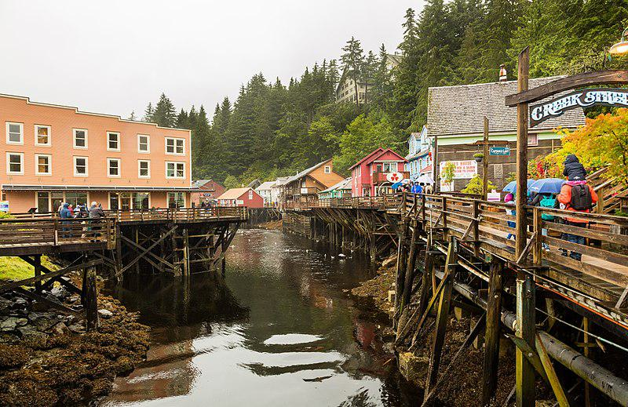

Caption for image source 2: Calle histórica Creek, Ketchikan, Alaska, Estados Unidos, 2017-08-16, DD 51 Historic Creek St, Ketchikan, Alaska, United States.

Example Question - "Does the Historic Creek St, Ketchikan experience different intensities of flow?"

Example Answer - "Yes, the Historic Creek Street, Ketchikan experiences different intensities of flow."

Additional Text Source 1 - In 2018, Ketchikan Harbour saw 40 different cruise ships making more than 500 stops in the harbour and bringing more than 1,073,000 visitors to Ketchikan. The Misty Fiords National Monument is one of the area's major attractions, and the Tongass National Forest has long been headquartered in Ketchikan, mostly in the city's historic Federal Building. (from: Ketchikan, Alaska)

Generated Question - Does the influx of over a million visitors in Ketchikan likely increase foot traffic on Creek Street's wooden walkways?

Generated Answer - Yes, the large number of visitors likely increases foot traffic on Creek Street's wooden walkways.

--- Entry for custom_id: d5bbd84e0dba11ecb1e81171463288e9 ---

Image Source 1 -

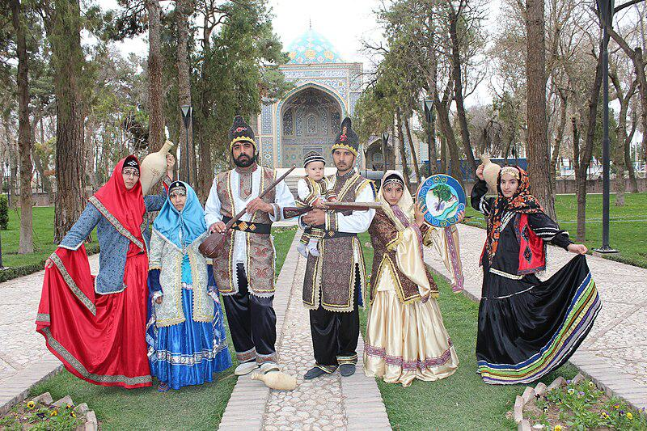

Caption for image source 1: Iranian family,gathered together wearing traditional clothes - Nishapur - Nowruz2014 Iranian family,gathered together wearing traditional clothes.

Example Question - "Are the heads of Iranian women covered in traditional clothing?"

Example Answer - "The heads of Iranian women are covered when they're in traditional clothing."

Additional Text Source 1 - Attempts at changing dress norms (and perspectives toward it) occurred in mid-1930s when pro-Western autocratic ruler Reza Shah banned Iranian women from wearing the veil entirely. Many types of male traditional clothing were also banned under the pretext that "Westerners now wouldn’t laugh at us". (from: Women in Iran)

Generated Question - Considering the historical ban on traditional dress, do the Iranian family members in the image still wear traditional clothing including head coverings?

Generated Answer - Yes, the Iranian family members in the image wear traditional clothing with head coverings despite past bans.

--- Entry for custom_id: d5bbd8e40dba11ecb1e81171463288e9 ---

Image Source 1 -

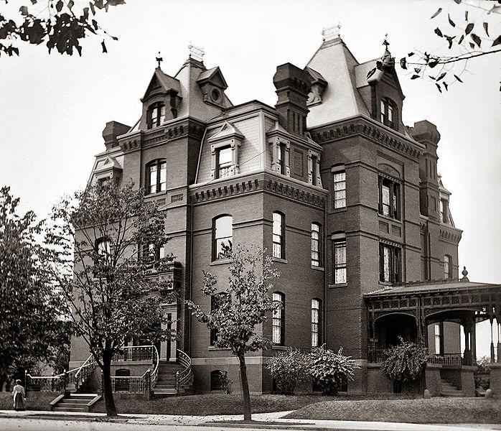

Caption for image source 1: Blaine Mansion - Washington, D.C. Residence of the Republican politician James G. Blaine located at 2000 Massachusetts Avenue, NW, in the Dupont Circle neighborhood of Washington, D.C...

Image Source 2 -

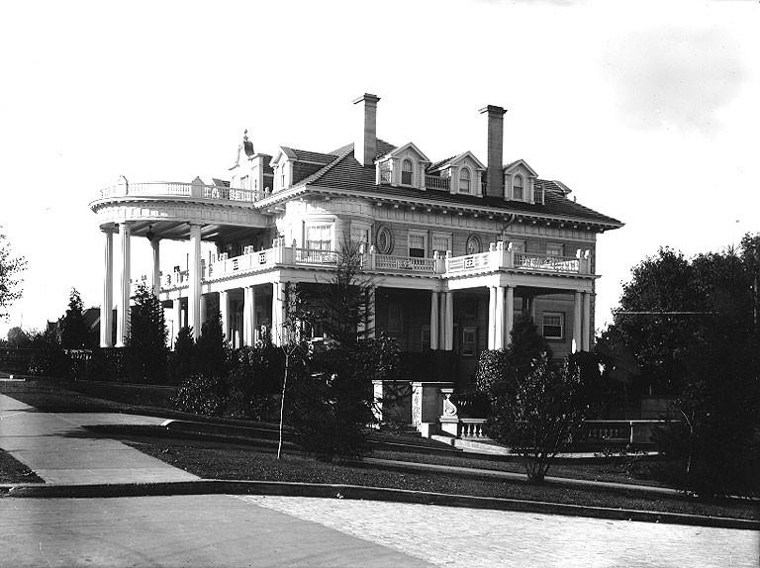

Caption for image source 2: William R Rust mansion, 1001 North I Street, Tacoma, Washington, ca 1910 (BAR 217).jpeg William R. Rust mansion, 1001 North I Street, Tacoma, Washington, ca. 1910.

Example Question - "Do both the William R. Rust Mansion and the Blaine Mansion have more than one chimney?"

Example Answer - "Both the William R. Rust Mansion and the Blaine Mansion have more than one chimney."

Additional Text Source 1 - One explanation of this change could be as a result of the damage it received after falling over the cliff at the end of "Trust Doesn't Rust", causing further malfunctions in its programming. (from: KARR (Knight Rider))

Generated Question - Do the Blaine Mansion and William R. Rust Mansion both have multiple chimneys despite their different architectural styles?

Generated Answer - Yes, both mansions have multiple chimneys regardless of their architectural differences.

--- Entry for custom_id: d5bbd9340dba11ecb1e81171463288e9 ---

Image Source 1 -

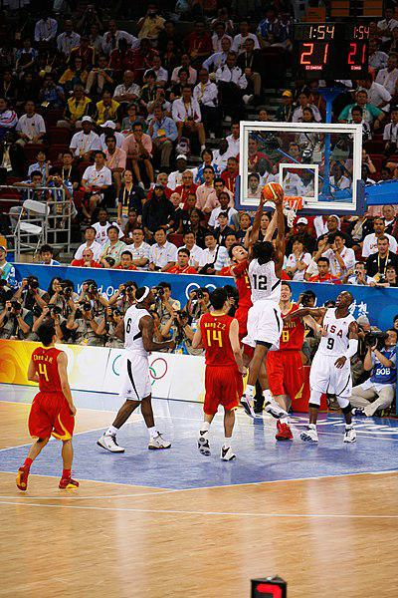

Caption for image source 1: USA vs. China Mens Basketball - Beijing 2008 Olympic Games (2752746092).

Image Source 2 -

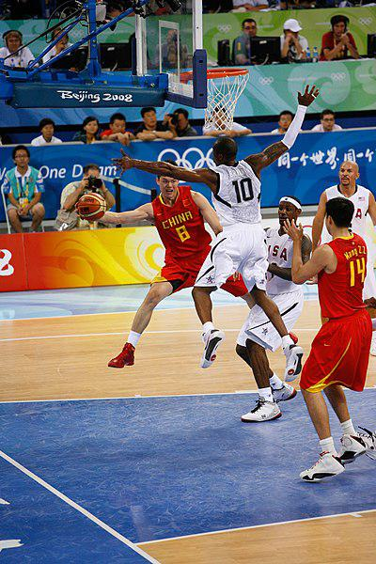

Caption for image source 2: USA vs. China Mens Basketball - Beijing 2008 Olympic Games (2751889351).

Example Question - "Which two colors did the Chinese team wear during the USA vs. China Mens Basketball game at the Beijing 2008 Olympic Games?"

Example Answer - "At the Beijing 2008 Olympic Games, the Chinese men's basketball team wore red and yellow during the USA vs. China Mens Basketball game."

Additional Text Source 1 - The China men's national basketball team (simplified Chinese: 中国国家男子篮球队; traditional Chinese: 中國國家男子籃球隊; pinyin: Zhōngguó Guójiā Nánzǐ Lánqiú Duì; nicknamed Team Dragon) represents the People's Republic of China in international basketball tournaments. The national team is governed by the Chinese Basketball Association (CBA). (from: China men's national basketball team)

Generated Question - Based on the images and text, which team is nicknamed "Team Dragon" in the USA vs. China basketball game at the Beijing 2008 Olympics?

Generated Answer - The Chinese men's basketball team is nicknamed "Team Dragon."

--- Entry for custom_id: d5bbd98e0dba11ecb1e81171463288e9 ---

Image Source 1 -

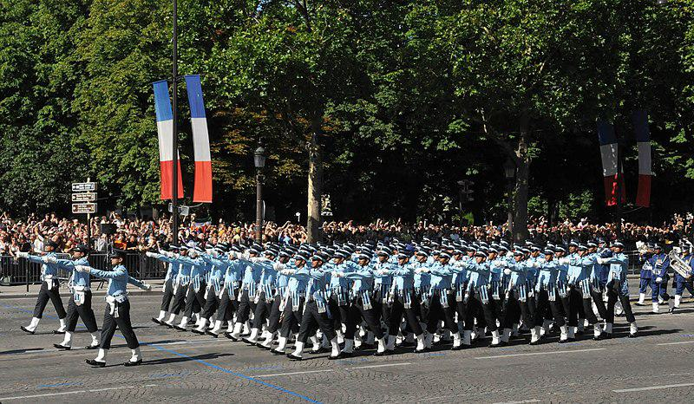

Caption for image source 1: Indian Air Force contingent as a part of the Bastille Day Parade of France, in Paris on July 14, 2009 Indian Air Force contingent as a part of the Bastille Day Parade of France, in Paris on July 14, 2009..

Image Source 2 -

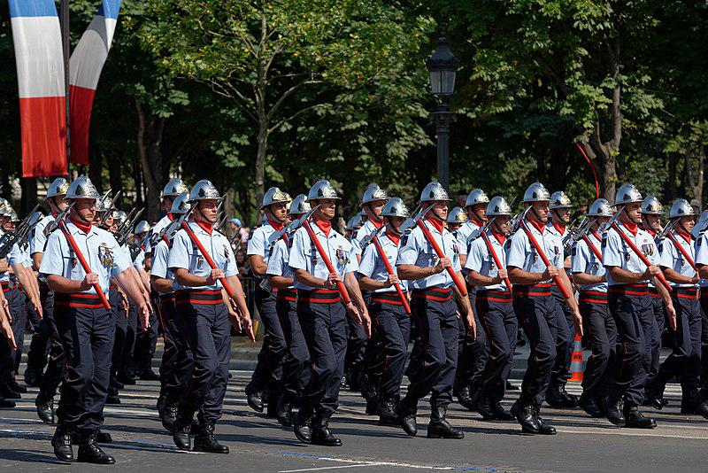

Caption for image source 2: Fire brigades Bastille Day 2013 Paris t112047 Paris Fire Brigade in the Bastille Day 2013 military parade on the Champs-Elysees in Paris. NCOs carry an axe; men carry a FAMAS.

Example Question - "Which group would be better equipped if a tree were felled in the middle of the parade; Brigade de sapeurs-pompiers de Paris or Indian Air Force contingent"

Example Answer - "Brigade de sapeurs-pompiers de Paris would be better-equipped if a tree were felled in the middle of the parade than the Indian Air Force contingent would be."

Additional Text Source 1 - In the Chilean Army, Brigadier is a one-star rank and General de Brigada is the immediately superior two-star rank. While the Chilean Air Force uses Comodoro for its one-star rank, two-star Air Force officers hold the rank of General de Brigada Aérea – literally 'air brigade general'. (from: Brigadier general)

Generated Question - Considering the ranks mentioned, which parade group is more likely to have officers with the rank equivalent to General de Brigada Aérea?

Generated Answer - The Indian Air Force contingent is more likely to have officers with the rank equivalent to General de Brigada Aérea.

--- Entry for custom_id: d5bbd9de0dba11ecb1e81171463288e9 ---

Image Source 1 -

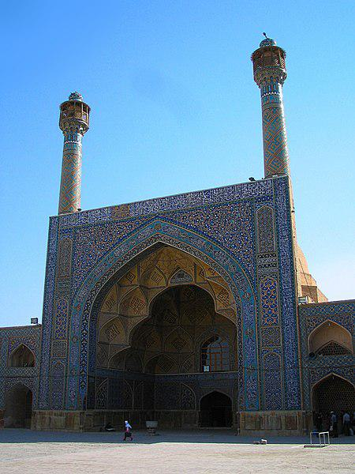

Caption for image source 1: Jame mosque portal Jameh Mosque of Isfahan.

Example Question - "Where is a clock located near the entrance to Jameh Mosque Oflsfahan?"

Example Answer - "A clock is located on a window above the door near the entrance to Jameh Mosque Oflsfahan."

Additional Text Source 1 - Jameh Mosque of Qazvin (Persian: مسجد جامع عتيق قزوین‎ – Masjid-e-Jameh Atiq Qazvin) is one of the oldest mosques in Iran, and is the grand, congregational mosque (Jameh Mosque) of Qazvin, in Qazvin Province, Iran. (from: Jameh Mosque of Qazvin)

Generated Question - How do the architectural features of the Jameh Mosque of Isfahan compare to those of the Jameh Mosque of Qazvin in terms of age and style?

Generated Answer - The Jameh Mosque of Isfahan has intricate tile work and tall minarets, while the Jameh Mosque of Qazvin is one of Iran's oldest mosques with a grand congregational style.

--- Entry for custom_id: d5bbda240dba11ecb1e81171463288e9 ---

Image Source 1 -

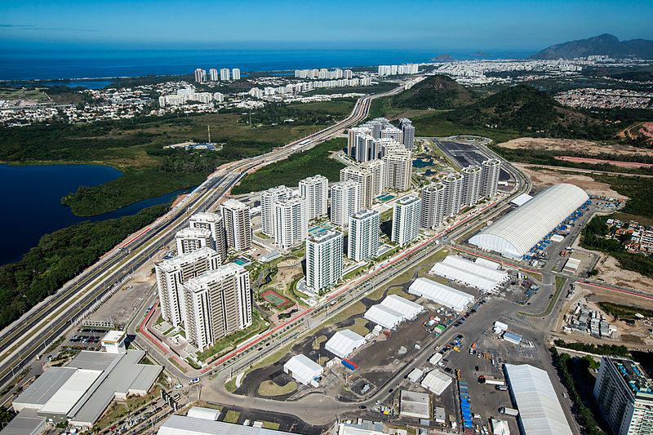

Caption for image source 1: Vila Olímpica Rio 2016.

Image Source 2 -

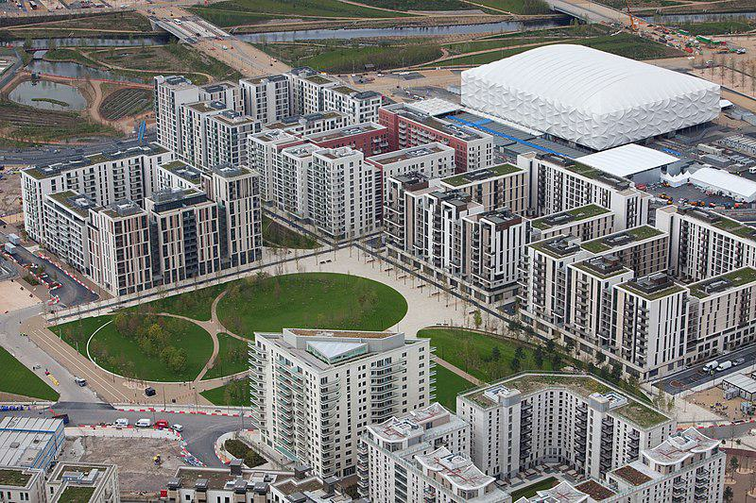

Caption for image source 2: Olympic Village, London, 16 April 2012 (1).

Example Question - "What is the primary color of the majority of buildings at both Olympic Park Rio and Olympic Park London?"

Example Answer - "The primary color of the majority of buildings at both Olympic Park Rio and Olympic Park London is white."

Additional Text Source 1 - The Olympic Zone encompassed all of the facilities within the 500 acres (2 km2) Olympic Park in Stratford. This park was developed on existing waste and industrial land, and is seven minutes by Olympic Javelin train from central London. (from: Venues of the 2012 Summer Olympics and Paralympics)

Generated Question - Are both the Olympic Villages in Rio and London located near large green spaces or parks?

Generated Answer - Yes, both Olympic Villages are situated near large green spaces or parks.

--- Entry for custom_id: d5bbda7e0dba11ecb1e81171463288e9 ---

Image Source 1 -

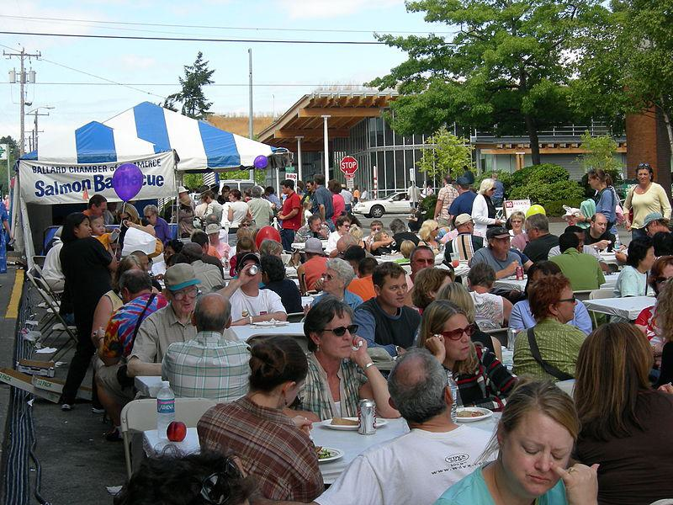

Caption for image source 1: Ballard Fest 2006 5.

Example Question - "What colors were the tent for the Ballard Chamber of Commerce Salmon Barbecue at Ballard Fest in 2006?"

Example Answer - "The tent for the Ballard Chamber of Commerce Salmon Barbecue at Ballard Fest in 2006 was blue and white."

Additional Text Source 1 - In 2005 there were 2,800 chambers of commerce in the United States and 102 chambers representing U.S. businesses overseas. According to the Association for Chamber of Commerce Executives (ACCE), there are approximately 3,000 chambers of commerce with at least one staff person and "thousands more established as strictly volunteer entities". (from: Chamber of commerce)

Generated Question - Considering the number of chambers of commerce in the U.S., how common is it for a local event like Ballard Fest to be organized by a chamber of commerce?

Generated Answer - It is common, as there are about 3,000 staffed chambers of commerce in the U.S. organizing local events.

--- Entry for custom_id: d5bbdace0dba11ecb1e81171463288e9 ---

Image Source 1 -

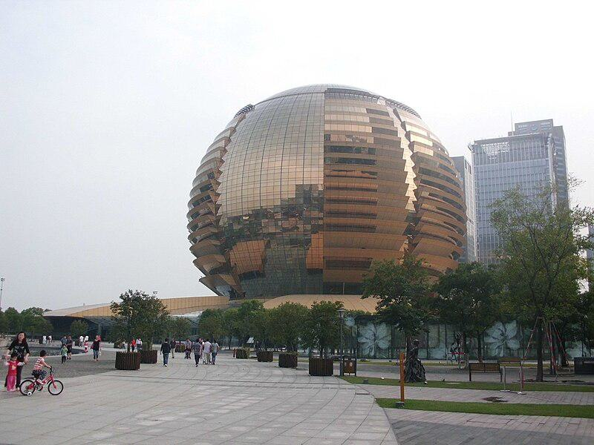

Caption for image source 1: Hangzhou International Conference Center 2 Hangzhou International Conference Center.

Example Question - "What grows around the exterior of the Hangzhou International Conference Center?"

Example Answer - "Trees grow around the Hangzhou International Conference Center."

Additional Text Source 1 - In front of the Hangzhou Grand Theatre was selected to build the Hangzhou International Conference Center including a 5 stars hotel of more than 400 rooms. (from: Carlos Ott)

Generated Question - Is the Hangzhou International Conference Center located near other buildings and a hotel with over 400 rooms?

Generated Answer - Yes, it is near other buildings and a 5-star hotel with more than 400 rooms.

--- Entry for custom_id: d5bbdb6e0dba11ecb1e81171463288e9 ---

Image Source 1 -

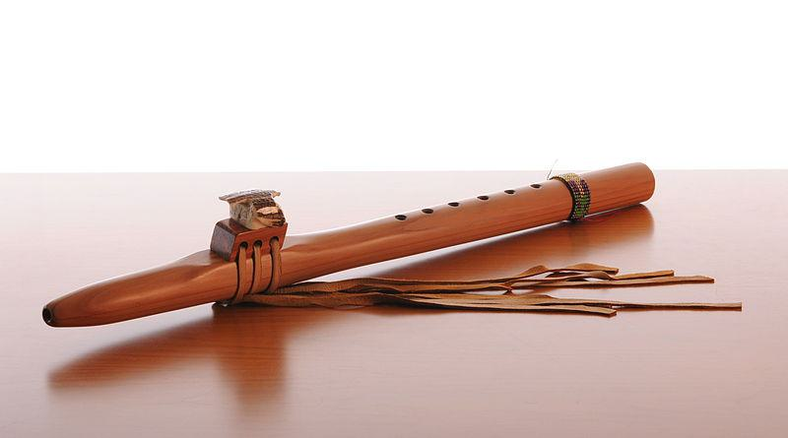

Caption for image source 1: Native american flute Native american flute.

Image Source 2 -

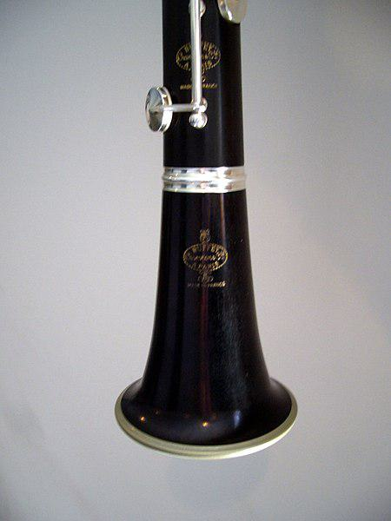

Caption for image source 2: Clarinet Bell Bell of a Buffet Bb clarinet..

Example Question - "Which has a larger area for sound to escape: Clarinet Bell or Native American flute?"

Example Answer - "The Clarinet Bell has a larger area for sound to escape than the Native American flute."

Additional Text Source 1 - Charles Neidich has had a basset clarinet with modern mechanics built by Schwenk & Seggelke, which, like the Stadler clarinet, has an angled barrel and as a bell has a Liebesfuß, which he turns backwards, although one can turn it forward. The different types and directions of the bell have an influence on the sound. (from: Basset clarinet)

Generated Question - Does the Native American flute or the clarinet have a bell that affects the sound differently due to its shape and direction?

Generated Answer - The clarinet has a bell whose shape and direction influence the sound, unlike the Native American flute.

--- Entry for custom_id: d5bbdbc80dba11ecb1e81171463288e9 ---

Image Source 1 -

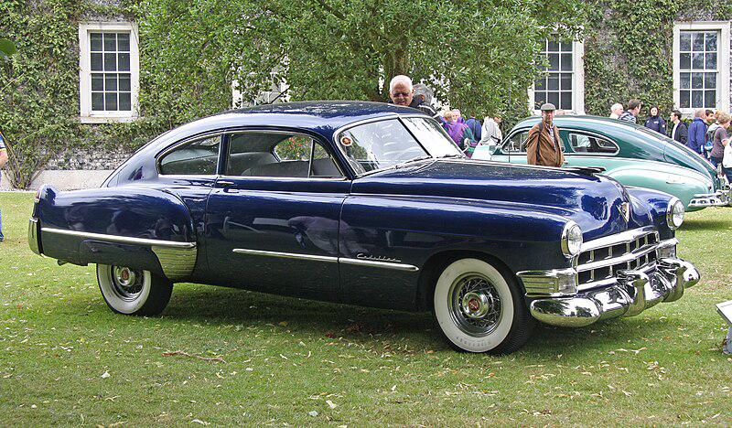

Caption for image source 1: 1949 Cadillac Series 61 Fastback - Flickr - exfordy (1).

Example Question - "Did the Cadillac Series 61 Fastback come as a four door sedan only?"

Example Answer - "No, it does not."

Additional Text Source 1 - The Fleetline was introduced late in the 1941 model year as a four-door sedan only. In 1942, a fastback two-door "Aerosedan" was also offered while the sedan was renamed "Sport Master". (from: Chevrolet Fleetline)

Generated Question - Did both the 1949 Cadillac Series 61 Fastback and the 1942 Chevrolet Fleetline offer a two-door fastback model?

Generated Answer - Yes, both offered a two-door fastback model.

--- Entry for custom_id: d5bbdc180dba11ecb1e81171463288e9 ---

Image Source 1 -

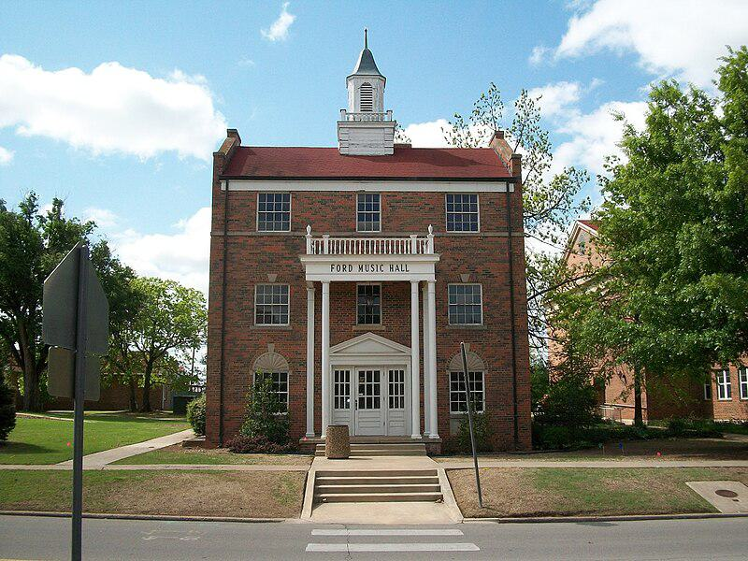

Caption for image source 1: Ford Music Hall This is the Ford Music Hall on OBU campus.

Example Question - "What color is the top of the spire on the Ford Music Hall on the OBU campus?"

Example Answer - "The top of the spire on the Ford Music Hall on the OBU campus is green."

Additional Text Source 1 - On, May 24, 1945, "Gold Star Park" was dedicated to OBU from the Senior Class of 1945. The monument stands today directly east of Ford Music Hall southwest of the intersection of University and Kickapoo streets. (from: Oklahoma Baptist University)

Generated Question - Is the Gold Star Park located east or west of the Ford Music Hall on the OBU campus?

Generated Answer - The Gold Star Park is located east of the Ford Music Hall on the OBU campus.

--- Entry for custom_id: d5bbdc5e0dba11ecb1e81171463288e9 ---

Image Source 1 -

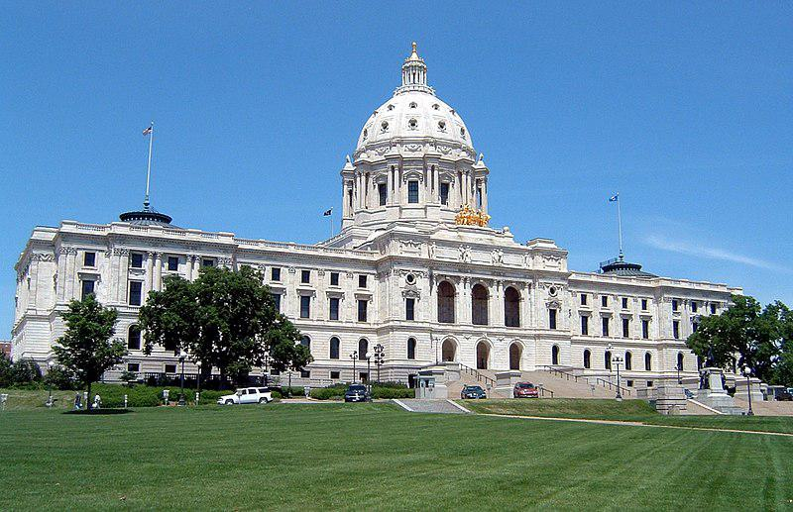

Caption for image source 1: Minnesota State Capitol.

Image Source 2 -

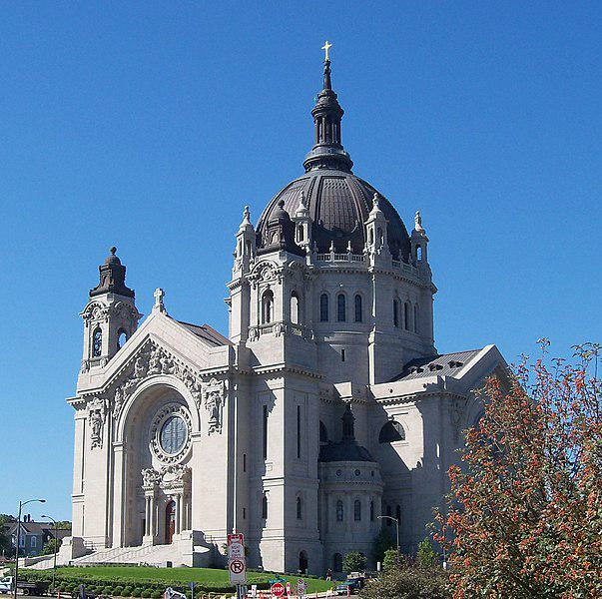

Caption for image source 2: Cathedral of Saint Paul (Minnesota) 5 Cathedral of Saint Paul in St. Paul, Minnesota, USA..

Example Question - "Is the tip of the golden cross on the Cathedral of Saint Paul in Minnesota thicker than the golden ball on top of the dome of the Minnesota State Capitol?"

Example Answer - "No, the tip of the golden cross on the Cathedral of Saint Paul in Minnesota is thinner."

Additional Text Source 1 - Its lowest level is surrounded by the "Golden Gallery" and its upper level supports a small dome from which rises a cross on a golden ball. (from: St Paul's Cathedral)

Generated Question - Does the Minnesota State Capitol have a golden ball beneath its dome's tip like the Cathedral of Saint Paul?

Generated Answer - No, only the Cathedral of Saint Paul has a golden ball beneath its dome's tip.

--- Entry for custom_id: d5bbdcb80dba11ecb1e81171463288e9 ---

Image Source 1 -

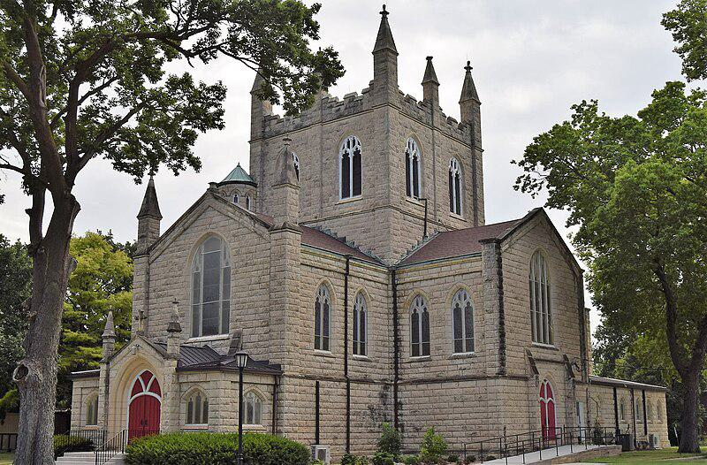

Caption for image source 1: Christ Cathedral Salina KS (cropped) Christ Cathedral.

Example Question - "When looking from the outside, are the windows of the Christ Cathedral in Salina, KS stained or opaque?"

Example Answer - "The windows Christ Cathedral in Salina, KS appear to be opaque when viewed from the outside of the building."

Additional Text Source 1 - The Cathedral of Christ the Saviour (Russian: Храм Христа́ Спаси́теля, tr. Khram Khristá Spasítelya, IPA: [xram xrʲɪˈsta spɐˈsʲitʲɪlʲə]) is a Russian Orthodox cathedral in Moscow, Russia, on the northern bank of the Moskva River, a few hundred metres southwest of the Kremlin. (from: Cathedral of Christ the Saviour)

Generated Question - Are the architectural styles of Christ Cathedral in Salina, KS and the Cathedral of Christ the Saviour in Moscow similar in terms of window design?

Generated Answer - No, Christ Cathedral has tall, narrow, opaque windows, while the Cathedral of Christ the Saviour has different Russian Orthodox window styles.

--- Entry for custom_id: d5bbdda80dba11ecb1e81171463288e9 ---

Image Source 1 -

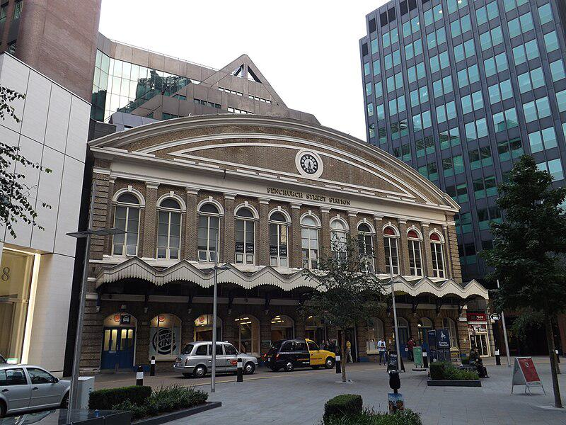

Caption for image source 1: Fenchurch Street railway station, September 2014 (2) Fenchurch Street railway station is today the terminus of the London, Tilbury and Southend Railway, and was originally built by the London and Blackwall Railway..

Example Question - "Where is the clock on the front of the Fenchurch Street station with respect to the rest of the building?"

Example Answer - "The clock on the front of the Fenchurch Street station is on the top and middle of the building."

Additional Text Source 1 - It was named Stepney, lying between Shadwell and a separate station called Limehouse, located within the Limehouse parish. The initial train service operated between a temporary terminus at Minories and Blackwall until 2 August 1841 when Fenchurch Street opened; the Commercial Railway was then renamed the London and Blackwall Railway (LBR). (from: Limehouse station)

Generated Question - Is Fenchurch Street station the original terminus of the London and Blackwall Railway before it was renamed?

Generated Answer - No, Fenchurch Street station opened after a temporary terminus at Minories and the railway was renamed after it opened.

--- Entry for custom_id: d5bbde520dba11ecb1e81171463288e9 ---

Image Source 1 -

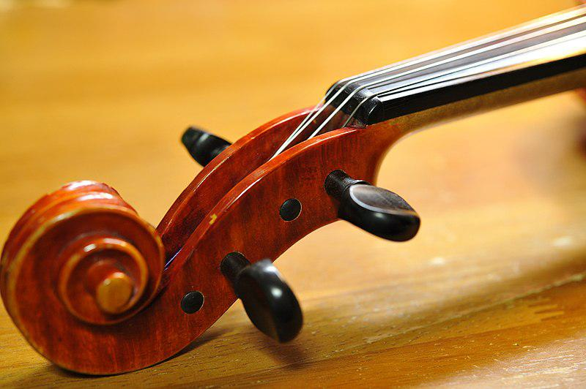

Caption for image source 1: Suzuki Violin No.580 4-4 (1982) pegbox.

Image Source 2 -

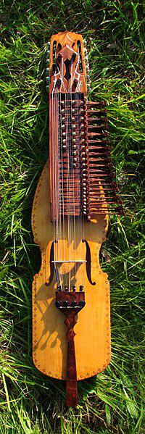

Caption for image source 2: Nyckelharpa built by fredrik soderstrom A swedish 3-row chromatic nyckelharpa built by Fredrik Soderstrom in 2008..

Example Question - "Which has a greater number of tuning mechanisms; swedish 3-row chromatic nyckelharpa or Suzuki Violin?"

Example Answer - "The Swedish 3-row chromatic nyckelharpa has more tuning mechanisms than a Suzuki violin."

Additional Text Source 1 - The first 3 books are mostly graded arrangements of music not originally written for solo violin, although book 1 contains several original compositions by Suzuki for violin & piano. These arrangements are drawn from folk tunes and from composers such as Bach, Telemann, Dvořák, Beethoven, Schubert, Handel, Paganini, Boccherini and Brahms. (from: Suzuki method)

Generated Question - Considering the Suzuki method's focus on violin music, which instrument has more tuning pegs, the Suzuki violin or the Swedish 3-row chromatic nyckelharpa?

Generated Answer - The Swedish 3-row chromatic nyckelharpa has more tuning pegs than the Suzuki violin.

--- Entry for custom_id: d5bbdea20dba11ecb1e81171463288e9 ---

Image Source 1 -



Caption for image source 1: Season's Greetings, Banksy (2) Season's Greetings, a mural by graffiti artist Banksy, stencilled onto a garage in Port Talbot, Wales in December 2018..

Example Question - "In Season's Greetings, a mural by graffiti artist Banksy, stencilled onto a garage in Port Talbot, Wales in December 2018, most of the mural is black and white. What is the one part of the mural that is a different color?"

Example Answer - "The boy's pink tongue is the one element that is not black and white on the Season's Greetings mural by graffiti artist Banksy, stenciled on a garage in Port Talbot, Wales in December 2018."

Additional Text Source 1 - Heterochromia (heterochromia iridum or heterochromia iridis) is an eye condition in which one iris is a different color from the other (complete heterochromia), or where a part of one iris is a different color from the remainder (partial heterochromia or sectoral heterochromia). (from: Eye color)

Generated Question - Does the boy in Banksy's "Season's Greetings" mural appear to have heterochromia based on the colors of his eyes?

Generated Answer - No, the boy's eyes in the mural appear to be the same color.

--- Entry for custom_id: d5bbdefc0dba11ecb1e81171463288e9 ---

Image Source 1 -

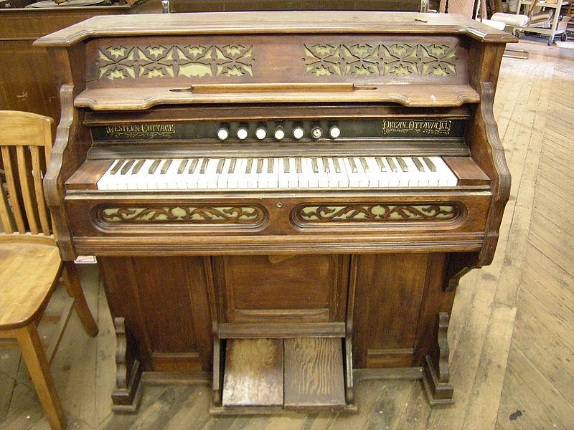

Caption for image source 1: Western Cottage pump organ.

Image Source 2 -

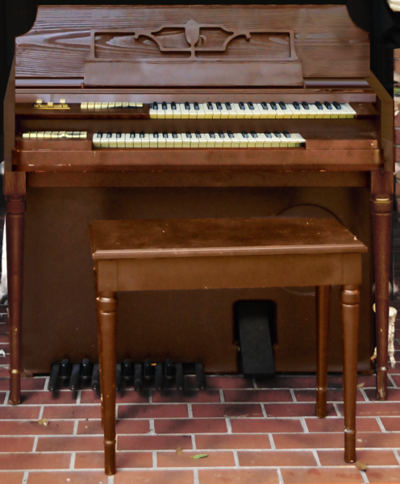

Caption for image source 2: Wurlitzer Model 44 Electrostatic Reed Organ.png.

Example Question - "On which organ, are more round visible stop knobs installed; Western Cottage pump organ or Wurlitzer Model 44 Electrostatic Reed Organ?"

Example Answer - "The Western Cottage pump organ has more round visible stop knobs installed compared to the Wurlitzer Model 44 Electrostatic Reed Organ."

Additional Text Source 1 - Among Wurlitzer's electronic instruments, beginning with electrostatic reed organs in 1947, the most important have been the fully electronic organs, especially the two-manual-and-pedals spinet type (from 1971 with synthesizer features) for domestic use. In the mid-1950s, Wurlitzer began manufacturing portable electric pianos. (from: Wurlitzer)

Generated Question - Which organ, the Western Cottage pump organ or the Wurlitzer Model 44 Electrostatic Reed Organ, is more likely to be fully electronic based on their design and history?

Generated Answer - The Wurlitzer Model 44 Electrostatic Reed Organ is more likely to be fully electronic, unlike the Western Cottage pump organ.

--- Entry for custom_id: d5bbdf420dba11ecb1e81171463288e9 ---

Image Source 1 -

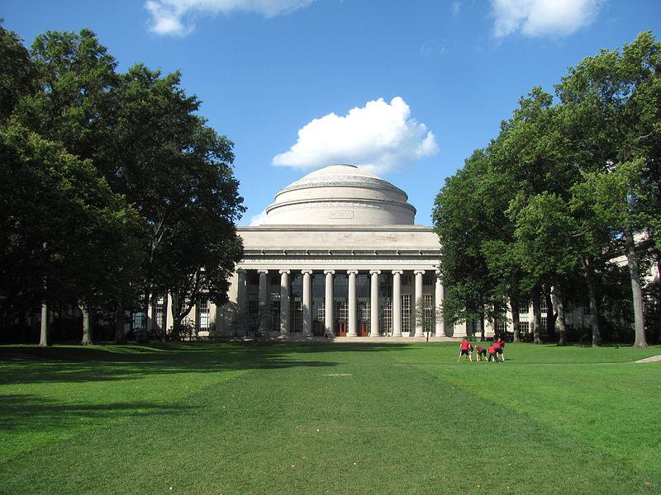

Caption for image source 1: Great Dome, Massachusetts Institute of Technology, Cambridge MA Great Dome, Massachusetts Institute of Technology, Cambridge Massachusetts.

Example Question - "What year is written in Roman numerals on the facade of the Great Dome Massachusetts Institute of Technology, Cambridge MA?"

Example Answer - "The year written in Roman numerals on the facade of the Great Dome Massachusetts Institute of Technolgy, Cambridge, MA, is 1916."

Additional Text Source 1 - MIT students retaliated for CPW in April 2006, when students posing as the "Howe & Ser Moving Co." abducted the 130-year-old, 1.7 ton Fleming House Cannon and moved it to their campus in Cambridge, Massachusetts, thus reprising a similar prank performed by Harvey Mudd College in 1986. (from: Hacks at the Massachusetts Institute of Technology)

Generated Question - Did the MIT students' 2006 prank involving the Fleming House Cannon occur near the Great Dome shown in the image?

Generated Answer - Yes, the prank took place on MIT's campus near the Great Dome in Cambridge, Massachusetts.

--- Entry for custom_id: d5bbdf920dba11ecb1e81171463288e9 ---

Image Source 1 -

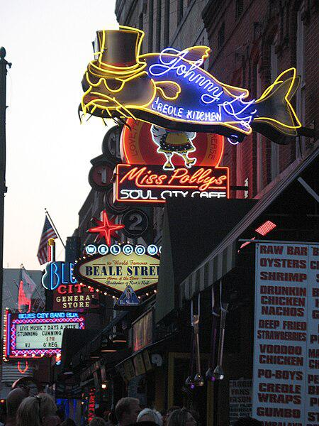

Caption for image source 1: Beale Street, Memphis.

Example Question - "What animal is depicted on the sign next to Miss Polly's on Beale Street?"

Example Answer - "A catfish is depicted on the sign next to Miss Polly's on Beale Street."

Additional Text Source 1 - Handy also wrote a song called "Beale Street Blues" in 1916 which influenced the change of the street's name from Beale Avenue to Beale Street. (from: Beale Street)

Generated Question - How does the neon sign of Johnny's Creole Kitchen on Beale Street reflect the street's musical and cultural history?

Generated Answer - The neon sign's vibrant, artistic design reflects Beale Street's lively musical and cultural heritage.

--- Entry for custom_id: d5bbdfe20dba11ecb1e81171463288e9 ---

Image Source 1 -

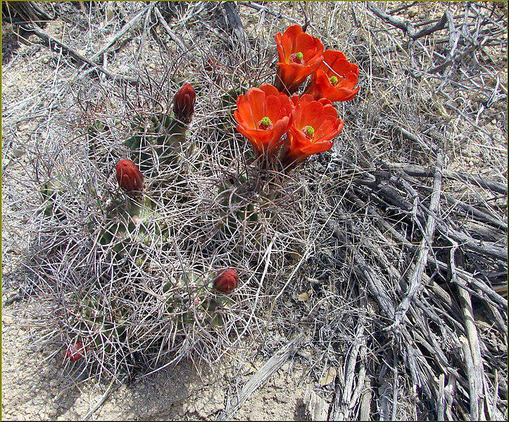

Caption for image source 1: Hedgehog Cactus Flowers, JTNP 4-13-13 (8689108275) (1 in a multiple picture set).

Example Question - "Are the Hedgehog Cactus's flowers petals slightly curled upward or downward?"

Example Answer - "The Hedgehog Cactus's flowers petals are slightly curled upward."

Additional Text Source 1 - Echinocereus viridiflorus is a species of cactus known by the common names nylon hedgehog cactus, green pitaya, and small-flowered hedgehog cactus. It is native to the central and south-central United States and northern Mexico, where it can be found in varied habitat types, including desert scrub, woodlands, dry grasslands, and short-grass prairie. (from: Echinocereus viridiflorus)

Generated Question - Are the Hedgehog Cactus flowers in the image more likely from Echinocereus viridiflorus based on their habitat and appearance?

Generated Answer - No, the flowers are bright red and the habitat looks desert-like, which differs from the green-flowered Echinocereus viridiflorus.

--- Entry for custom_id: d5bbe0280dba11ecb1e81171463288e9 ---

Image Source 1 -

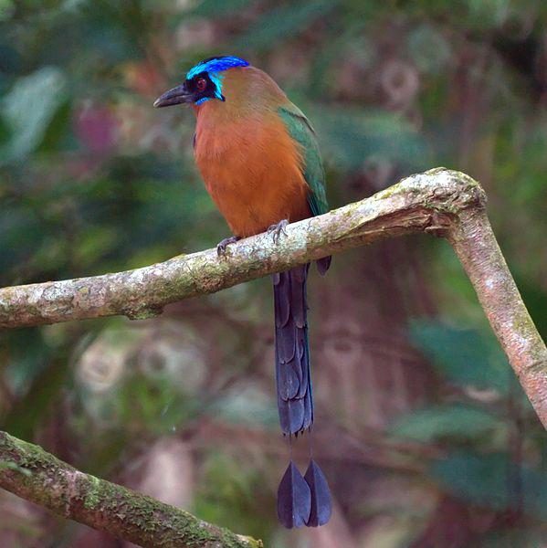

Caption for image source 1: Blue-crowned Mot Mot (5535489339).

Image Source 2 -



Caption for image source 2: Northern Royal Flycatcher (6901657644).

Example Question - "Do the Northern Royal Flycatcher and the Blue-crowned Mot Mot have the same head shape?"

Example Answer - "The Northern Royal Flycatcher and the Blue-crowned Mot Mot do not have the same shaped head."

Additional Text Source 1 - The IOC considers the northern royal flycatcher and three other royal flycatcher taxa to be separate species and places them in the family Tityridae. The South American Classification Committee of the American Ornithological Society (SACC-AOS) and the Clements taxonomy consider the four to be subspecies of the widespread royal flycatcher (Onychorhynchus coronatus sensu lato). (from: Northern royal flycatcher)

Generated Question - Are the Blue-crowned Mot Mot and Northern Royal Flycatcher classified in the same bird family according to the IOC?

Generated Answer - No, the Northern Royal Flycatcher is in the family Tityridae, while the Blue-crowned Mot Mot is not.

--- Entry for custom_id: d5bbe0820dba11ecb1e81171463288e9 ---

Image Source 1 -



Caption for image source 1: Crassula tecta 03.

Image Source 2 -



Caption for image source 2: Brain Cactus (Stenocactus multicostatus).

Example Question - "Does the brain cactus or the Crassula tecta appear to be softer to the touch?"

Example Answer - "Crassula tecta looks softer than the brain cactus."

Additional Text Source 1 - Crassula muscosa, synonyms Crassula lycopodioides and Crassula pseudolycopodioides, is a succulent plant native to South Africa and Namibia, belonging to the family of Crassulaceae and to the genus Crassula. It is a houseplant grown worldwide and commonly known as rattail crassula, watch chain, lizard's tail, zipper plant and princess pines. (from: Crassula muscosa)

Generated Question - Are Crassula tecta and Crassula muscosa likely to have similar textures compared to the spiky brain cactus?

Generated Answer - Yes, Crassula tecta and Crassula muscosa likely have softer textures than the spiky brain cactus.

--- Entry for custom_id: d5bbe0c80dba11ecb1e81171463288e9 ---

Image Source 1 -

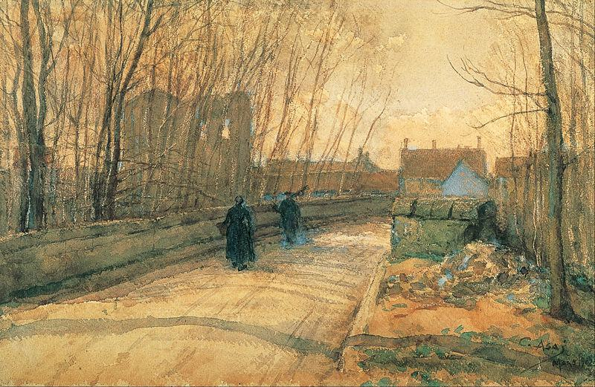

Caption for image source 1: Asai Chu - Bridge in Grez-sur-Loing - Google Art Project.

Example Question - "How many people are walking on the bridge in the "Bridge in Grez-sur-Loing" painting by Asai Chū?"

Example Answer - "Two people are walking on the bridge in the "Bridge in Grez-sur-Loing" painting by Asai Chū."

Additional Text Source 1 - There he studied, like Kuroda, Kume, and Okada, under Raphaël Collin at the Académie Colarossi, sponsored by the Monbusho. From Autumn 1901 to Spring the following year, Wada stayed in Grez-sur-Loing with Asai Chū, where they painted and penned their Grez Diaries (愚劣日記). (from: Wada Eisaku)

Generated Question - Did Wada Eisaku and Asai Chū both paint in Grez-sur-Loing while studying under Raphaël Collin?

Generated Answer - Yes, both Wada Eisaku and Asai Chū painted in Grez-sur-Loing while studying under Raphaël Collin.

--- Entry for custom_id: d5bbe1180dba11ecb1e81171463288e9 ---

Image Source 1 -

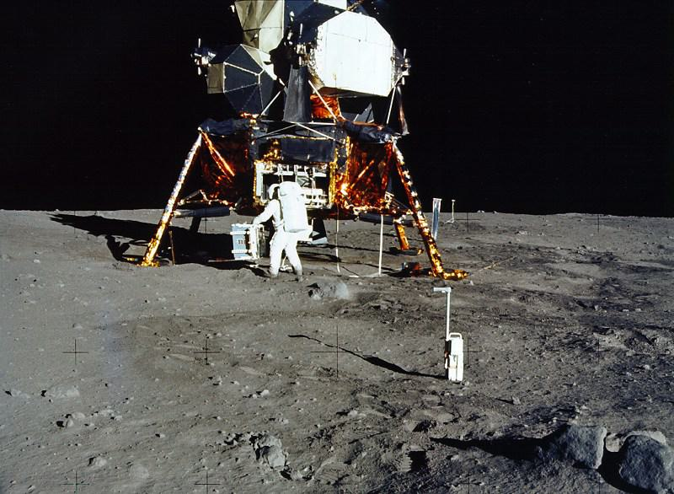

Caption for image source 1: Apollo 11 1998 scan.

Example Question - "What was the sheen on the exterior of the lunar module during the Apollo 11 mission?"

Example Answer - "There was a metallic sheen on the exterior of the Apollo 11 lunar module."

Additional Text Source 1 - Kennedy's goal was accomplished on the Apollo 11 mission when astronauts Neil Armstrong and Buzz Aldrin landed their Apollo Lunar Module (LM) on July 20, 1969, and walked on the lunar surface, while Michael Collins remained in lunar orbit in the command and service module (CSM), and all three landed safely on Earth on July 24. (from: Apollo program)

Generated Question - Did the Apollo 11 lunar module land on the moon before or after Kennedy's goal was set?

Generated Answer - The Apollo 11 lunar module landed on the moon after Kennedy's goal was set.

--- Entry for custom_id: d5bbe1680dba11ecb1e81171463288e9 ---

Image Source 1 -

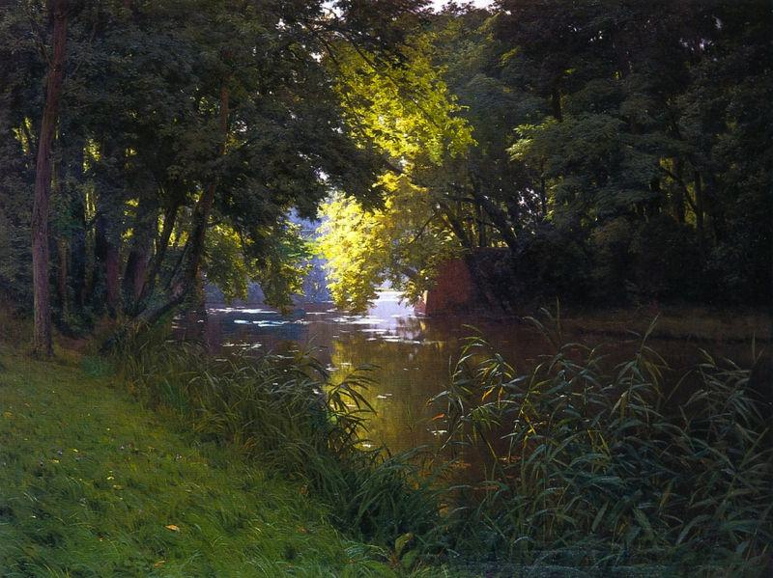

Caption for image source 1: Henri Biva, By the river, signed Henri Biva (lower left) oil on canvas, 122 by 162 cm.

Example Question - "In the painting "By the river" is it day time or night time?"

Example Answer - "It is day time."

Additional Text Source 1 - It is joined by the Panjnad at Mithankot. Beyond this confluence, the river, at one time, was named the Satnad River (sat = "seven", nadī = "river"), as the river now carried the waters of the Kabul River, the Indus River and the five Punjab rivers. (from: Indus River)

Generated Question - Could the river in the painting "By the river" be part of the Indus River system after the Panjnad confluence?

Generated Answer - Yes, it could be part of the Indus River system after the Panjnad confluence.

--- Entry for custom_id: d5bbe2120dba11ecb1e81171463288e9 ---

Image Source 1 -

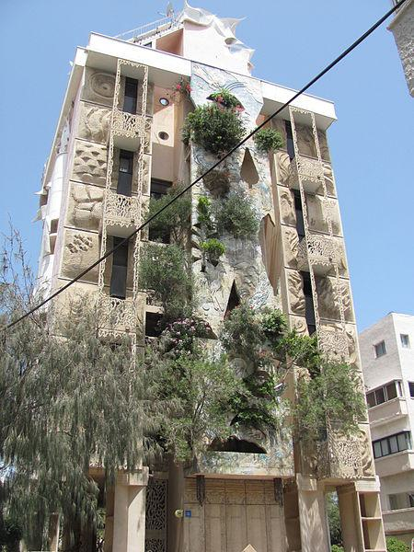

Caption for image source 1: Tel Aviv Crazy House Back The back side of "The Crazy House" in Tel Aviv..

Example Question - "What is growing out of the windows of the Crazy House in Tel Aviv?"

Example Answer - "Trees are growing out of the windows of the Crazy House in Tel Aviv."

Additional Text Source 1 - "Crazy Frog in the House" is a song by Crazy Frog released as the second single from the album Crazy Frog Presents More Crazy Hits. (from: Crazy Frog in the House)

Generated Question - Is the "Crazy House" in Tel Aviv related to the "Crazy Frog in the House" song by Crazy Frog?

Generated Answer - No, the "Crazy House" is a building, unrelated to the "Crazy Frog in the House" song.

--- Entry for custom_id: d5bbe28a0dba11ecb1e81171463288e9 ---

Image Source 1 -

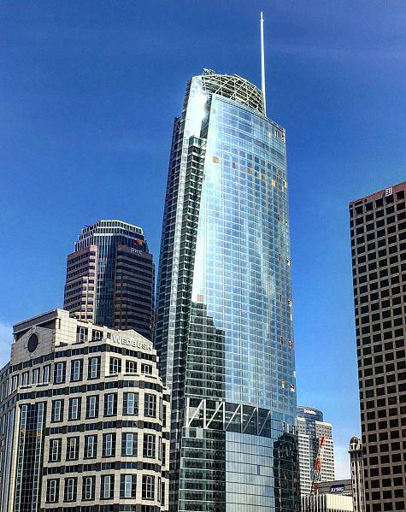

Caption for image source 1: Wilshire Grand Wilshire Grand / Korean Air Building.

Example Question - "Can the PWC and the Wedbush buildings be seen from a window inside the Wilshire Grand / Korean Air Building?"

Example Answer - "Yes, the PWC and the Wedbush buildings can be seen from a window inside the Wilshire Grand."

Additional Text Source 1 - Korean Air owns five hotels: two KAL hotels on Jeju island, the Hyatt in Incheon; Waikiki Resort in Hawaii, and a hotel/office building called the Wilshire Grand Tower in Los Angeles. This building in downtown Los Angeles houses the largest InterContinental Hotel in the Americas in what is the tallest building in Los Angeles. (from: Korean Air)

Generated Question - Is the Wilshire Grand Tower both the tallest building in Los Angeles and home to the largest InterContinental Hotel in the Americas?

Generated Answer - Yes, the Wilshire Grand Tower is the tallest building in Los Angeles and houses the largest InterContinental Hotel in the Americas.

--- Entry for custom_id: d5bbe32a0dba11ecb1e81171463288e9 ---

Image Source 1 -

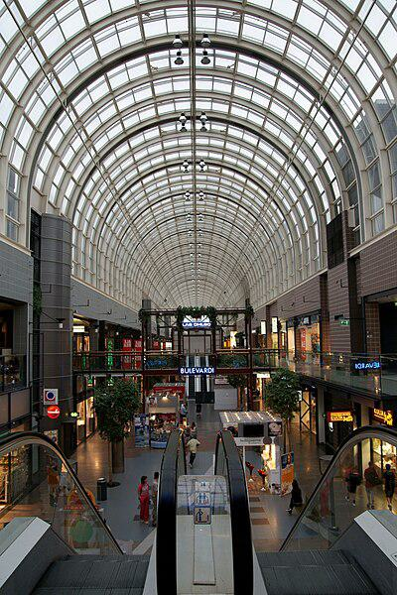

Caption for image source 1: Itäkeskus shopping centre Photo from Itakeskus shopping centre in Helsinki, Finland..

Example Question - "Is the ceiling above the Itäkeskus shopping centre opaque?"

Example Answer - "No, the ceiling is not opaque."

Additional Text Source 1 - Varissuo has several schools, a library, an underground ice arena, a Lutheran church, a health centre, a post office and a social security (KELA) office. In addition, the Itäkeskus shopping centre is located in Varissuo, as well as a University of Turku teacher training school (Turun normaalikoulu) and Turku International School. (from: Varissuo)

Generated Question - Is the Itäkeskus shopping centre located in the same area as the University of Turku teacher training school and Turku International School?

Generated Answer - No, the Itäkeskus shopping centre is in Helsinki, not in Varissuo where the schools are.

--- Entry for custom_id: d5bbe3980dba11ecb1e81171463288e9 ---

Image Source 1 -

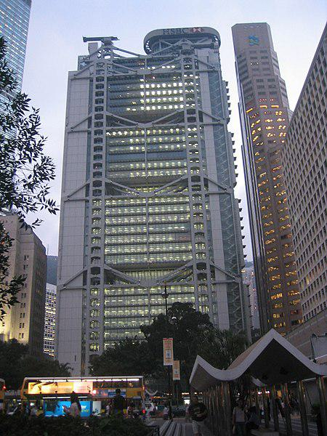

Caption for image source 1: HSBC Hong Kong Headquarters.

Example Question - "Are there any trees near the HSBC Hong Kong Headquarters building which are taller than the building?"

Example Answer - "No, there are no trees taller than the HSBC Hong Kong Headquarters building."

Additional Text Source 1 - HSBC Main Building is a headquarters building of The Hongkong and Shanghai Banking Corporation, which is today a wholly owned subsidiary of London-based HSBC Holdings. It is located on the southern side of Statue Square near the location of the old City Hall, Hong Kong (built in 1869, demolished in 1933). (from: HSBC Building (Hong Kong))

Generated Question - Is the HSBC Hong Kong Headquarters located near the old City Hall site in Hong Kong?

Generated Answer - Yes, it is located near the old City Hall site in Hong Kong.

--- Entry for custom_id: d5bbe3de0dba11ecb1e81171463288e9 ---

Image Source 1 -

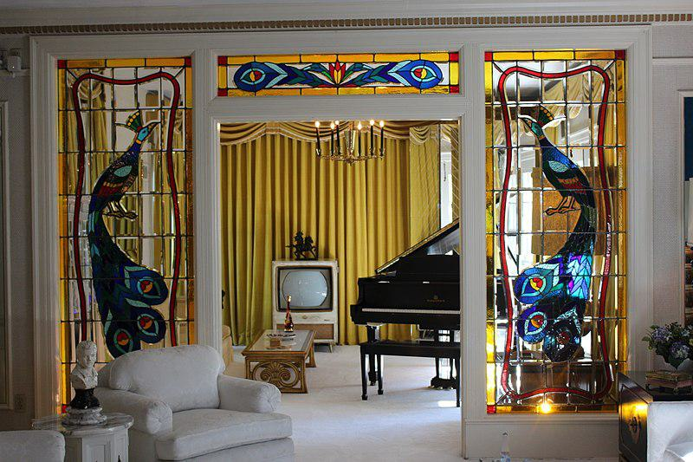

Caption for image source 1: Music Room in Graceland, the home of Elvis Presley Entering Graceland, the music room, adjacent to the living room, is one of the first rooms tourists see. A grand piano and a television are prominent features of the music room..

Image Source 2 -



Caption for image source 2: TrophyRoom Records in Elvis Trophy Room.

Example Question - "Does only one room in Graceland have light fixtures that hang from the ceiling?"

Example Answer - "More than one room in Graceland has light fixtures that hang from the ceiling."

Additional Text Source 1 - Ceiling Dome – Also called the light source(s) are hidden behind a translucent dome typically made of glass, with some combination of frosting and surface texturing to diffuse the light. These can be flush-mount fixtures mounted into the ceiling, or semi-flush fixtures separated by a small distance (usually about 3–12"). (from: Light fixture)

Generated Question - Does the music room in Graceland have visible hanging light fixtures unlike the diffused ceiling dome lights described?

Generated Answer - Yes, the music room has visible hanging light fixtures, not diffused ceiling dome lights.

--- Entry for custom_id: d5bbe42e0dba11ecb1e81171463288e9 ---

Image Source 1 -

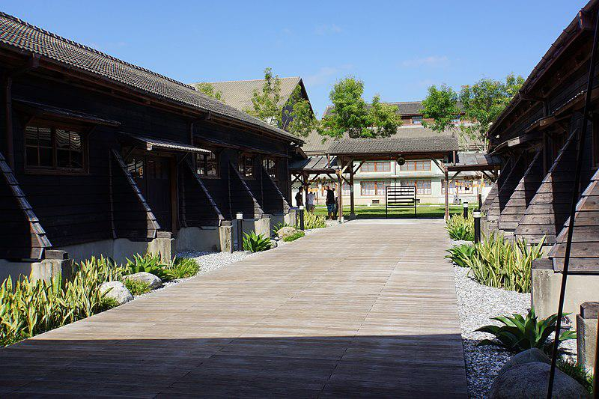

Caption for image source 1: 花蓮文化創意產業園區 Hualien Creative and Cultural Industries Park - panoramio.

Example Question - "There are potted plants at Hualien Creative and Cultural Industries Park?"

Example Answer - "Hualien Creative and Cultural Industries Park has potted plants."

Additional Text Source 1 - Museums and historical buildings in Hualien County include Dongli Story House, Hualien Sugar Factory, Pine Garden, Saoba Stone Pillars, Hualien Cultural and Creative Industries Park, Lintian Police Substation and Old Lintian Police Station, Chihsing Tan Katsuo Museum and Hualien County Stone Sculptural Museum. (from: Hualien County)

Generated Question - Is the Hualien Creative and Cultural Industries Park surrounded by other historical sites in Hualien County?

Generated Answer - Yes, it is surrounded by several historical sites in Hualien County.

--- Entry for custom_id: d5bbe4d80dba11ecb1e81171463288e9 ---

Image Source 1 -

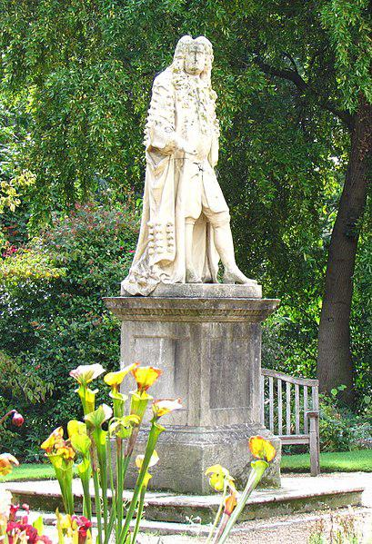

Caption for image source 1: Statue of Hans Sloane, Chelsea Physic Garden.

Image Source 2 -

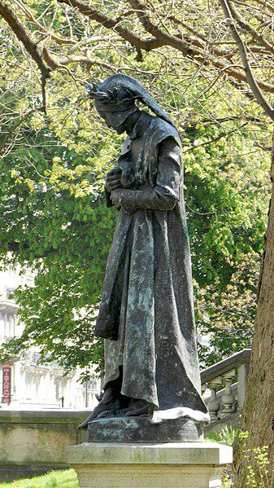

Caption for image source 2: Statue of Dante Alghieri, Paris 21 April 2013 01 Statue of Dante, kicking the head of Bocca degli Abati when met in the ninth circle of Inferno (Canto 32), Garden Michel-Foucault, rue des Ecoles, Paris, France..

Example Question - "Is the statue of Dante Alghieri in Paris generally lighter or darker in color than the statue of Hans Sloane in Chelsea?"

Example Answer - "The statue of Dante Alghieri in Paris is generally darker in color than the statue of Hans Sloane in Chelsea."

Additional Text Source 1 - The memorials in the churchyard of Chelsea Old Church, near the river, illustrate much of the history of Chelsea. These include Lord and Lady Dacre (1594/1595); Lady Jane Cheyne (1698); Francis Thomas, "director of the china porcelain manufactory"; Sir Hans Sloane (1753); Thomas Shadwell, Poet Laureate (1692). (from: Chelsea, London)

Generated Question - Are the statues of Hans Sloane and Dante Alghieri located in garden settings with historical or literary significance?

Generated Answer - Yes, Hans Sloane's statue is in Chelsea Physic Garden with historical ties, and Dante's statue is in a Paris garden referencing his literary work.

--- Entry for custom_id: d5bbe5320dba11ecb1e81171463288e9 ---

Image Source 1 -

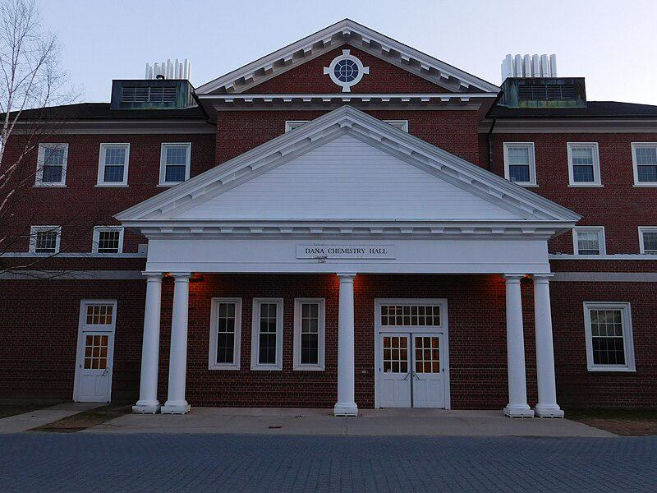

Caption for image source 1: Dana Chemistry Hall Bates college Dana Chemistry Hall, Campus of Bates College.

Image Source 2 -

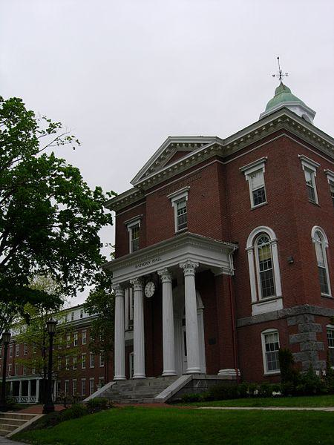

Caption for image source 2: Hathorn Hall Hathorn Hall.

Example Question - "How many more columns are there at Dana Chemistry Hall, Campus of Bates College than Hathorn Hall?"

Example Answer - "Dana Chemistry Hall, Campus of Bates College has one more column than Hathorn Hall."

Additional Text Source 1 - The quad is surrounded by numerous buildings and off campus houses such as: Rand Hall (1905) and the Gomes Chapel (1913), Parker Hall (1856), Hathorn Hall (1856), and Dana Chemistry Hall (1965), Coram Library (1902) and Carnegie Science Hall (1913), Lindholm House, Milliken House) (1902), and Whittier House (1902). (from: Historic Quad)

Generated Question - Which building at Bates College is newer, Dana Chemistry Hall or Hathorn Hall?

Generated Answer - Dana Chemistry Hall is newer than Hathorn Hall.

--- Entry for custom_id: d5bbe5820dba11ecb1e81171463288e9 ---

Image Source 1 -

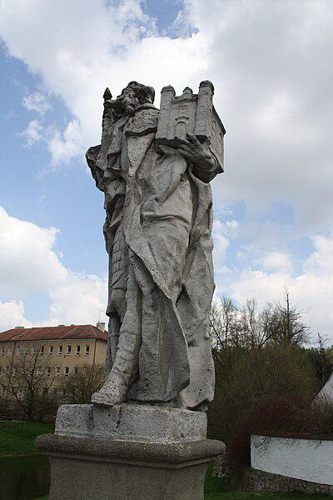

Caption for image source 1: Statue of Saint Leopold in Náměšť nad Oslavou, Třebíč District Statue of Saint Leopold in Namest nad Oslavou..

Image Source 2 -

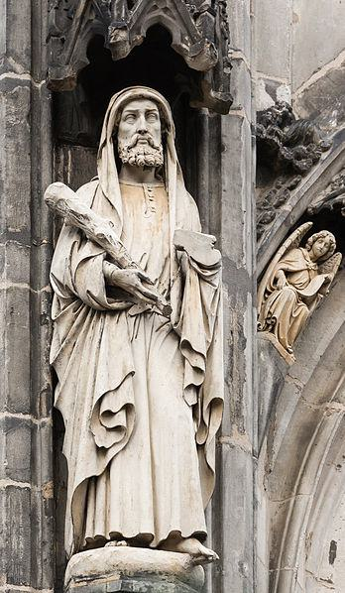

Caption for image source 2: Saint Jude statue, Cathedral, Aachen, Germany Statue of Saint Jude, Apostle, Cathedral, Aachen, Germany..

Example Question - "Which statue is holding something larger: the Statue of Saint Leopold in Namest nad Oslavou or the Statue of Saint Jude in Aachen, Germany?"

Example Answer - "The Statue of Saint Leopold in Namest nad Oslavou is holding something larger than what the statue of Saint Jude in Aachen, Germany is holding."

Additional Text Source 1 - Saint Jude Thaddeus was made patron saint of the parish after a month by Cardinal Santos as proposed by Father Provincial Herman Kondring, SVD.The present site of St. Jude Parish, with an area of 2,989.10 square metres (32,174.4 sq ft), was donated by Cardinal Santos. (from: National Shrine of Saint Jude (Philippines))

Generated Question - Considering their held objects, which statue likely symbolizes a protector of a place, Saint Leopold or Saint Jude?

Generated Answer - The Statue of Saint Leopold likely symbolizes a protector of a place, holding a model of a building.

--- Entry for custom_id: d5bbe6220dba11ecb1e81171463288e9 ---

Image Source 1 -

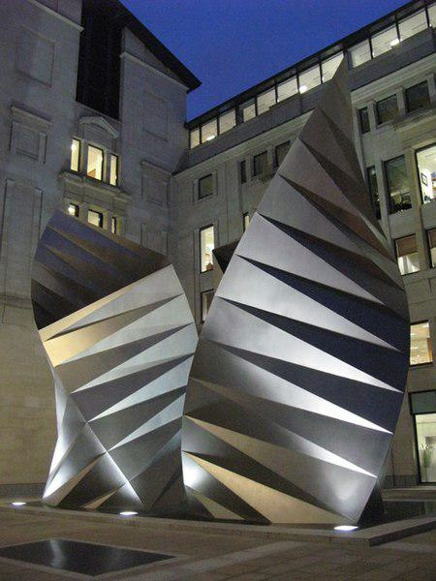

Caption for image source 1: Large modern metal sculptures, Warwick Lane - Amen Corner, EC4 (2) - geograph.org.uk - 1274658 Large modern metal sculptures, Warwick Lane / Amen Corner, EC4 (2).

Example Question - "Where are the lights the are used to light up the metal sculptures at the Warwick Lane - Amen Corner?"

Example Answer - "The lights that are used to light up the metal sculptures at the Warwick Lane- Amen Corner are on the ground in front of the sculptures."

Additional Text Source 1 - They would reach the final "Amen" as they turned the corner into Ave Maria Lane, after which they would chant Hail Mary (Ave Maria in Latin).Ave Maria Lane is home to the Grade I listed building Stationers' Hall, the livery hall of the Worshipful Company of Stationers and Newspaper Makers since 1670. (from: Ave Maria Lane)

Generated Question - Are the metal sculptures at Warwick Lane located near the Grade I listed Stationers' Hall on Ave Maria Lane?

Generated Answer - Yes, the sculptures are near Ave Maria Lane, where Stationers' Hall is located.

--- Entry for custom_id: d5bbe6720dba11ecb1e81171463288e9 ---

Image Source 1 -

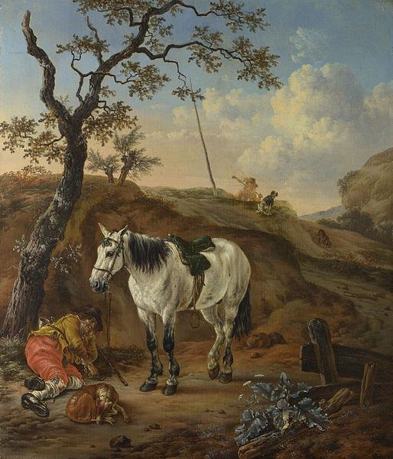

Caption for image source 1: A White Horse standing by a Sleeping Man, Pieter Verbeeck A White Horse standing by a Sleeping Man. about 1652. Pieter Cornelisz. Verbeeck. National Gallery, London. Oil on oak. 31.8 x 27 cm. NG1009.

Image Source 2 -

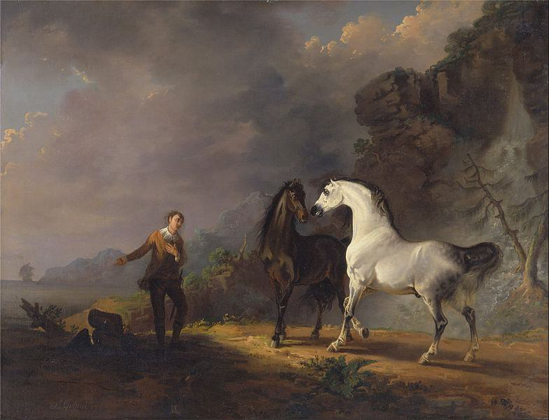

Caption for image source 2: Sawrey Gilpin - Gulliver Addressing the Houyhnhnms - Google Art Project Bay01, 401 Signed and dated, lower left: "S. Gilpin. 1709.".

Example Question - "How many more horses are depicted in the painting Gulliver Addressing the Houyhnhnms by Sawrey Gilpin than in the painting A White Horse Standing by a Sleeping Man by Peter Verbeeck?"

Example Answer - "One more horse is depicted in the painting Gulliver Addressing the Houyhnhnms by Sawrey Gilpin than in the painting A White Horse Standing by a Sleeping Man by Peter Verbeeck."

Additional Text Source 1 - The White Horse at Ebbsfleet, formerly the Ebbsfleet Landmark, colloquially the Angel of the South, was a planned white horse statue to be built in the Ebbsfleet Valley in Kent, England. Designed by Mark Wallinger to faithfully resemble a thoroughbred horse, but at 33 times life size, the colossal sculpture was to be 50 metres (160 ft) high. (from: White Horse at Ebbsfleet)

Generated Question - Considering the size difference, how does the planned White Horse at Ebbsfleet compare to the horses in the paintings by Verbeeck and Gilpin?

Generated Answer - The White Horse at Ebbsfleet is vastly larger, planned to be 33 times life size, unlike the normal-sized horses in the paintings.

--- Entry for custom_id: d5bbe6c20dba11ecb1e81171463288e9 ---

Image Source 1 -



Caption for image source 1: Albert Lebourg, c. 1895, Notre Dame de Paris.

Example Question - "Is the sun low or high in the sky in the painting Notre Dame de Paris?"

Example Answer - "It is low."

Additional Text Source 1 - Notre-Dame de Paris (French: [nɔtʁə dam də paʁi] (listen); meaning "Our Lady of Paris"), referred to simply as Notre-Dame, is a medieval Catholic cathedral on the Île de la Cité in the 4th arrondissement of Paris. (from: Notre-Dame de Paris)

Generated Question - Is the Notre-Dame cathedral in the painting shown during daytime or at sunset?

Generated Answer - It is shown at sunset, indicated by the low sun and orange sky.

--- Entry for custom_id: d5bbe7080dba11ecb1e81171463288e9 ---

Image Source 1 -



Caption for image source 1: Araschnia levana bgiu.

Image Source 2 -



Caption for image source 2: Atrophaneura alcinous.

Example Question - "Does the Atrophaneura Alcinous butterfly have the same or a different number of antennae as the Araschnia Levana butterfly?"

Example Answer - "The Atrophaneura Alcinous butterfly has the same number of antennaes as the Araschnia Levana butterfly."

Additional Text Source 1 - Papiliones angulati has thus been re-defined to apply only to a clade: Nymphalis sensu lato, and to specifically exclude Papilio atalanta [→ Vanessa], P. cardui [→ Cynthia], P. levana, and P. prorsa [→ Araschnia]. (from: Nymphalini)

Generated Question - Are Araschnia levana and Atrophaneura alcinous butterflies classified in the same clade according to the Nymphalini redefinition?

Generated Answer - No, Araschnia levana is excluded from the Nymphalini clade, unlike Atrophaneura alcinous.

--- Entry for custom_id: d5bbe7620dba11ecb1e81171463288e9 ---

Image Source 1 -



Caption for image source 1: Yellow Moth (Dysphania sagana), BSRC, Cambodia Yellow Moth (Dysphania sagana), BSRC, Cambodia.

Example Question - "What is the pattern on the back of the Yellow Moth (Dysphania sagana)?"

Example Answer - "The pattern on the back of the Yellow Moth, also known as Dysphania sagana, is spotted."

Additional Text Source 1 - The nine-spotted moth or yellow belted burnet (Amata phegea, formerly Syntomis phegea) is a moth in the family Erebidae ("tiger moths"). The species was first described by Carl Linnaeus in his 1758 10th edition of Systema Naturae. (from: Nine-spotted moth)

Generated Question - How do the wing patterns of the Yellow Moth (Dysphania sagana) and the nine-spotted moth (Amata phegea) differ?

Generated Answer - The Yellow Moth has spotted yellow and black wings, while the nine-spotted moth has distinct nine spots on darker wings.

--- Entry for custom_id: d5bbe7b20dba11ecb1e81171463288e9 ---

Image Source 1 -



Caption for image source 1: Lenoir, Charles-Amable - A la Recherche du Temps Perdu To the Return of Times Lost.

Image Source 2 -

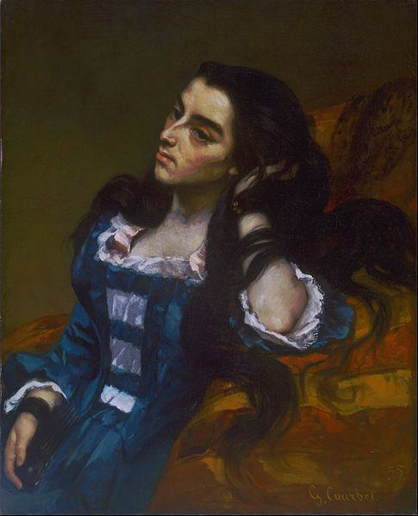

Caption for image source 2: Gustave Courbet, French - Spanish Woman - Google Art Project.

Example Question - "Do the paintings Spanish Woman by Gustave Courbet and To the Return of Times Lost by Charles Amable Lenoir show women with very long hair?"

Example Answer - "Yes, both of these women in the paintings have very long hair."

Additional Text Source 1 - Little is known of Hiffernan after 1880. A woman reported to Juliette Courbet (1831–1915), the sister of Gustave Courbet, in a letter of 18 December 1882, that "the beautiful Irish girl" was in Nice, where she sold antiques and some pictures by Courbet. (from: Joanna Hiffernan)

Generated Question - Considering the paintings and the additional text, is it likely that the woman in "Spanish Woman" by Courbet is Joanna Hiffernan with long dark hair?

Generated Answer - Yes, the woman in "Spanish Woman" is likely Joanna Hiffernan, who had long dark hair.

--- Entry for custom_id: d5bbe80c0dba11ecb1e81171463288e9 ---

Image Source 1 -



Caption for image source 1: 2016-05-29 12-09-30 triathlon-belfort.

Image Source 2 -



Caption for image source 2: 2018-05-27 09-45-50 triathlon-belfort.

Example Question - "In the Belfort Triathlon during the biking portion of the event, do all participants where the same type of footwear?"

Example Answer - "No, they do not all wear the same footwear."

Additional Text Source 1 - In 2010, racing in France, he had his first experience racing in long distance triathlon. In 2012, he took 7th place at the ITU Long Distance Triathlon World Championships. (from: Nikolay Yaroshenko)

Generated Question - Considering the Belfort Triathlon images and Nikolay Yaroshenko's long-distance triathlon experience, do all triathletes wear the same footwear during the biking segment?

Generated Answer - No, triathletes wear different types of footwear during the biking segment.

--- Entry for custom_id: d5bbe8520dba11ecb1e81171463288e9 ---

Image Source 1 -

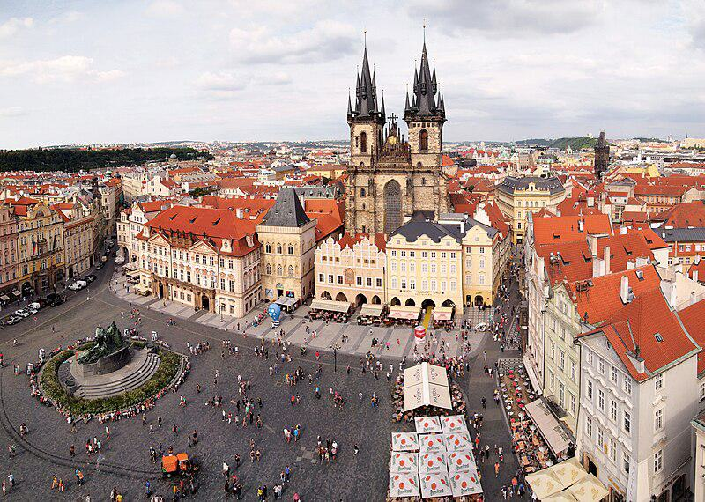

Caption for image source 1: Prague - Old Town Square 5 Old Town Square and Church of Our Lady in front of Tyn, Prague..

Example Question - "What color roof is most frequently encountered in the city of Prague?"

Example Answer - "An orange roof is most frequently encountered in the city of Prague."

Additional Text Source 1 - Inner Ring Road (The City Ring "MO"): Once completed it will surround the wider central part of the city. The longest city tunnel in Europe with a length of 5.5 kilometres (3.4 miles) and five interchanges has been completed to relieve congestion in the north-western part of Prague. (from: Prague)

Generated Question - Does the Old Town Square in Prague lie inside the area surrounded by the Inner Ring Road?

Generated Answer - Yes, the Old Town Square is inside the central part surrounded by the Inner Ring Road.

--- Entry for custom_id: d5bbe8a20dba11ecb1e81171463288e9 ---

Image Source 1 -

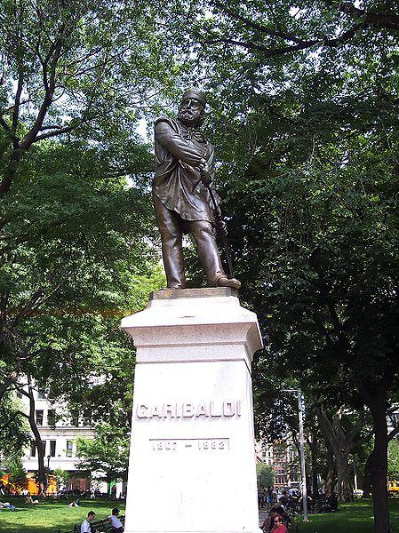

Caption for image source 1: Garibaldi Washington Square Park.

Image Source 2 -

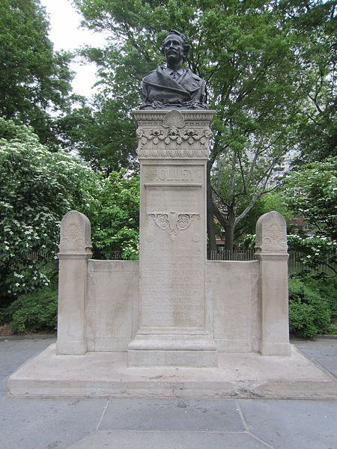

Caption for image source 2: Washington Square Park, Manhattan (2014) - 12 Washington Square Park, Manhattan (2014).

Example Question - "Are the statues of Garibaldi and Holley in Washington Square Park both full bodied?"

Example Answer - "No, the statues of Garibaldi and Holley in Washington Square Park are both not full bodied."

Additional Text Source 1 - In 1927, Garibaldi was made into a large wilderness park called Garibaldi Provincial Park. Named after Mount Garibaldi, this 1,946.5 square kilometre park was established to protect the rich geological history, diverse vegetation, iridescent waters, abundant wildlife, and rugged mountains, many of which are capped by glaciers. (from: Mount Garibaldi)

Generated Question - Considering the Garibaldi statue in Washington Square Park and the Garibaldi Provincial Park, do both represent full-bodied figures or natural landscapes?

Generated Answer - The Garibaldi statue represents a full-bodied figure, while Garibaldi Provincial Park represents natural landscapes.

--- Entry for custom_id: d5bbe8f20dba11ecb1e81171463288e9 ---

Image Source 1 -

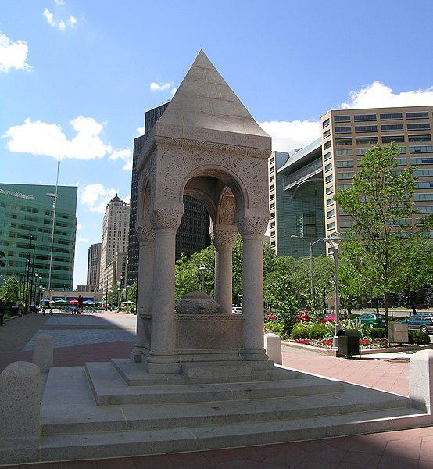

Caption for image source 1: BagleyMemorialFountainDetroit Bagley Memorial Fountain in Detroit MI.

Example Question - "What color are the flowers next to the Bagley Memorial Fountain in Detroit?"

Example Answer - "The flowers next to the Bagley Memorial Fountain in Detroit are red."

Additional Text Source 1 - The house, built in 1889 for John N. Bagley, son of former Michigan governor John J. Bagley, is among the oldest surviving nineteenth century French Renaissance Revival mansions in Detroit. The Bagley family commissioned the Bagley Memorial Fountain, designed in Romanesque Revival architecture, the only remaining work by Henry Hobson Richardson in the Detroit area. (from: John N. Bagley House)

Generated Question - Is the Bagley Memorial Fountain in Detroit designed in the same architectural style as the John N. Bagley House?

Generated Answer - No, the fountain is Romanesque Revival, while the house is French Renaissance Revival.

--- Entry for custom_id: d5bbe94c0dba11ecb1e81171463288e9 ---

Image Source 1 -

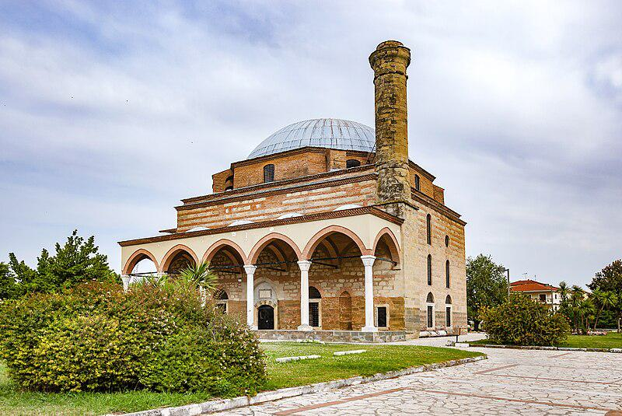

Caption for image source 1: Trikala Greece Kursum Mosque 3 Kursum Mosque or Osman Shah Mosque in Trikala, Thessaly, Greece.

Example Question - "Does the Osman Shah Mosque have fewer than three support pillars?"

Example Answer - "The Osman Shah Mosque does not have fewer than three support pillars."

Additional Text Source 1 - The Osman Shah Mosque (Greek: Τέμενος Οσμάν Σαχ) or Kursum Mosque (Κουρσούμ Τζαμί, from Turkish: kurşun camii, lit.  'Leaden Mosque') is a 16th-century Ottoman mosque in the city of Trikala in Greece. (from: Osman Shah Mosque)

Generated Question - Is the Osman Shah Mosque in Trikala, Greece an example of 16th-century Ottoman architecture with a lead-covered dome?

Generated Answer - Yes, it is a 16th-century Ottoman mosque with a lead-covered dome.

--- Entry for custom_id: d5bbe99c0dba11ecb1e81171463288e9 ---

Image Source 1 -

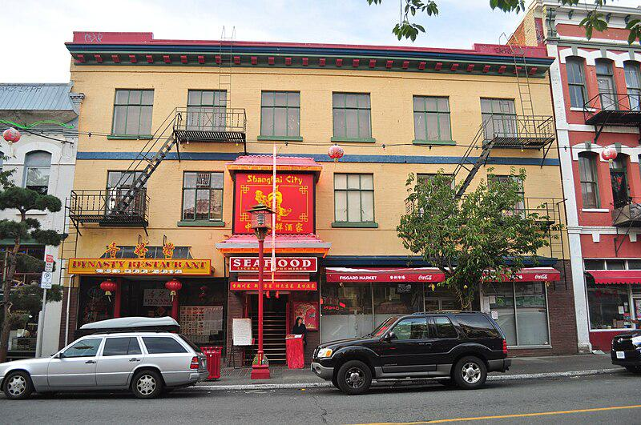

Caption for image source 1: Victoria, BC - On Hing & Brothers Store (building) 02 (20312909999) On Hing & Brothers Store (building), 546-52 Fisgard Street, Victoria, British Columbia..

Example Question - "What is the color of the trashcans on 546-52 Fisgard Street in British Columbia?"

Example Answer - "The trashcans on British Columbia's 546-52 Fisgard Street are red."

Additional Text Source 1 - The courthouse building was designed by Francis Rattenbury, who also designed the British Columbia Parliament Buildings and the Empress Hotel in Victoria, and the lavishly decorated second Hotel Vancouver. The 556-room Hotel Vancouver, opened in 1939 and the third by that name, is across the street with its copper roof. (from: Vancouver)

Generated Question - Are the buildings on Fisgard Street in Victoria, BC, similar in architectural style to the Hotel Vancouver designed by Francis Rattenbury?

Generated Answer - No, the buildings on Fisgard Street have simpler, commercial styles unlike the lavish Hotel Vancouver.

--- Entry for custom_id: d5bbe9e20dba11ecb1e81171463288e9 ---

Image Source 1 -

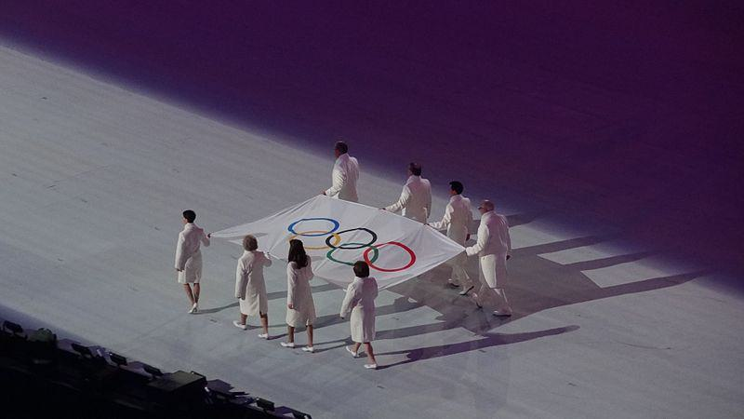

Caption for image source 1: Olympic flag, 2014 Winter Olympics opening ceremony Olympic flag, 2014 Winter Olympics opening ceremony.

Example Question - "What color of clothing did the people who carried Olympic flag at the 2014 Winter Olympics opening ceremony wear?"

Example Answer - "The clothing the people who carried Olympic flag at the 2014 Winter Olympics opening ceremony wore was white clothing."

Additional Text Source 1 - The 2014 Winter Olympics then became the first Winter Games to hold competitions before the opening ceremony. As mandated by the Olympic Charter, various elements frame the Opening Ceremony of a celebration of the Olympic Games. (from: Olympic Games ceremony)

Generated Question - Did the Olympic flag bearers at the 2014 Winter Olympics opening ceremony wear colorful or plain clothing?

Generated Answer - They wore plain white clothing.

--- Entry for custom_id: d5bbea3c0dba11ecb1e81171463288e9 ---

Image Source 1 -

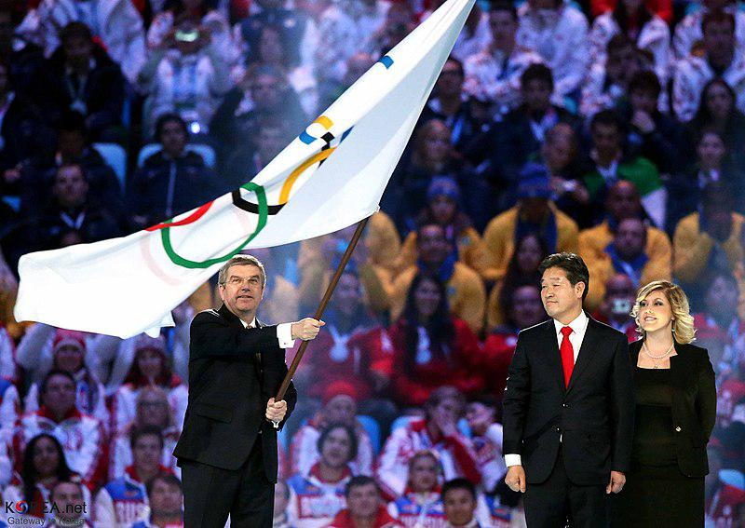

Caption for image source 1: KOCIS Korea PyeongChang Sochi Olympic Closing Ceremony 05 (12760822764) Korea.net / Korean Culture and Information Service (Korean Olympic Committee).

Image Source 2 -



Caption for image source 2: KOCIS Korea PyeongChang Sochi Olympic Closing Ceremony 03 (12760521283) Korea.net / Korean Culture and Information Service (Korean Olympic Committee).

Example Question - "How many Olympic officials waved the white Olympic flag at the 2014 Sochi Winter Olympics closing ceremony?"

Example Answer - "Two Olympic officials waved the white Olympic flag at the 2014 Sochi Winter Olympics closing ceremony."

Additional Text Source 1 - The closing ceremony of the 2014 Winter Olympics was held on 23 February 2014 from 20:14 to 22:25 MSK (UTC+4) at the Fisht Olympic Stadium in Sochi, Russia. It was designed to show Russian culture, through a European perspective, and featured performances by Yuri Bashmet, Valery Gergiev, Denis Matsuev, Hibla Gerzmava, and Tatiana Samouil, among others. (from: 2014 Winter Olympics closing ceremony)

Generated Question - Did the 2014 Sochi Winter Olympics closing ceremony include the waving of the Olympic flag by more than one official?

Generated Answer - Yes, two Olympic officials waved the Olympic flag at the closing ceremony.

--- Entry for custom_id: d5bbea8c0dba11ecb1e81171463288e9 ---

Image Source 1 -



Caption for image source 1: 2000 olympic torch.

Image Source 2 -

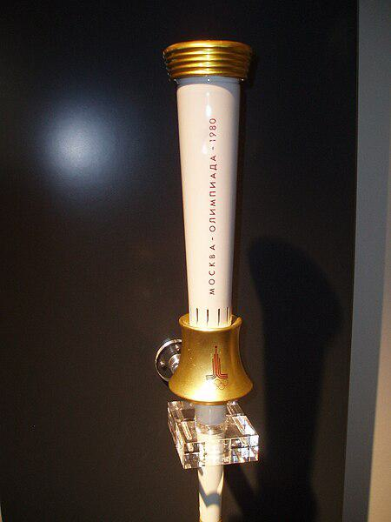

Caption for image source 2: Moscow torch.

Example Question - "What two colors do the 2000 Sydney Olympic torch and the 1980 Moscow torch have in common?"

Example Answer - "The Sydney Olympic torch and the 1980 Moscow torch both have gold and white."

Additional Text Source 1 - She is also author of the Olympic Torch Relay section of the "Official Report of the XXVII Olympiad, Sydney 2000 Olympic Games. Volume Two - Celebrating The Games". (from: 2000 Summer Olympics torch relay)

Generated Question - How do the designs of the 2000 Sydney and 1980 Moscow Olympic torches differ in shape and color emphasis?

Generated Answer - The Sydney torch is sleek and curved with blue and white, while the Moscow torch is straight with gold and white.

--- Entry for custom_id: d5bbeae60dba11ecb1e81171463288e9 ---

Image Source 1 -

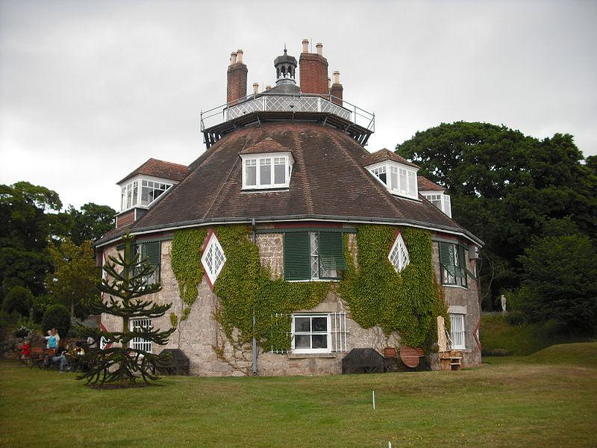

Caption for image source 1: A La Ronde from south A La Ronde, Lympstone, Exmouth, from the south.

Image Source 2 -

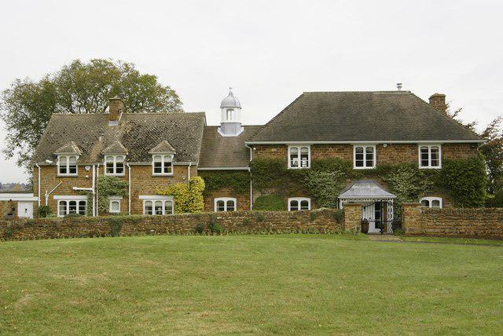

Caption for image source 2: Unusual house - geograph.org.uk - 1527069 Unusual house in Shotteswell, Warwickshire..

Example Question - "What is growing on both A La Ronde in Lympstone and the Unusual House in Shotteswell, Warwickshire?"

Example Answer - "Ivy is growing on both A La Ronde in Lympstone and the Unusual House in Shotteswell, Warwickshire."

Additional Text Source 1 - ""A freehold estate consisting of a mansion house of handsome elevation called Courtlands with lawn, pleasure ground, garden, shrubberies and stables, coach house, graperies, hothouses, greenhouse and all other suitable offices and buildings. "The next owner was William Francis Spicer (1763-1853), who previously owned Weare House. (from: Lympstone Manor, Exmouth)

Generated Question - Considering the architectural styles and surroundings, which property likely has more extensive garden features, A La Ronde or Courtlands estate?

Generated Answer - Courtlands estate likely has more extensive garden features than A La Ronde.

--- Entry for custom_id: d5bbeb360dba11ecb1e81171463288e9 ---

Image Source 1 -

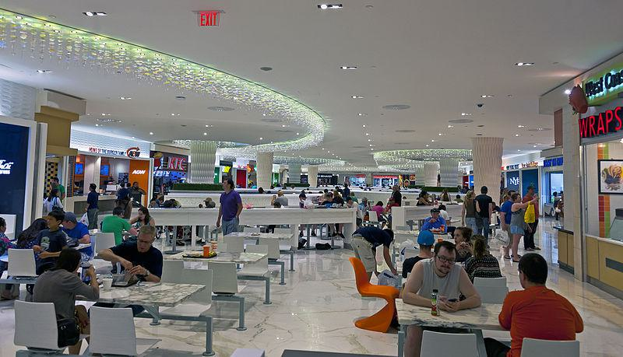

Caption for image source 1: Food court restaurants and seating area, West Edmonton Mall Seating area in middle of food court, West Edmonton Mall.

Image Source 2 -

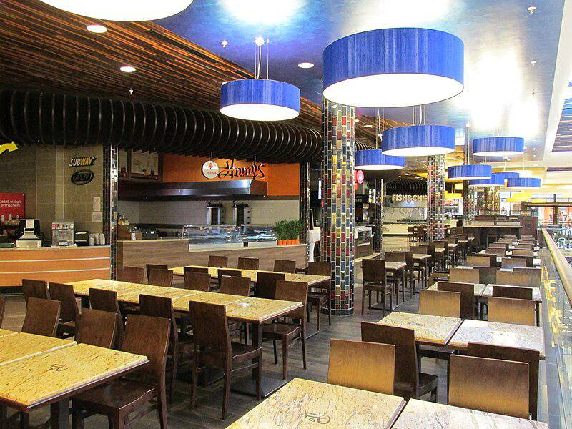

Caption for image source 2: Mall of Berlin food court empty 2 Empty food court at Mall of Berlin on a Sunday evening..

Example Question - "Are the chairs in the Mall of Berlin's food court the same color as the chairs in the West Edmonton Mall food court?"

Example Answer - "No, the chairs are different colors between the food courts."

Additional Text Source 1 - Metropolis at Metrotown (commonly referred to as Metrotown) is a three-storey shopping mall complex in Metrotown, Burnaby, British Columbia, Canada. Opened in 1986, it is the largest mall in British Columbia, and the third-largest in Canada, behind Alberta's West Edmonton Mall and Ontario's Square One Shopping Centre, with 27 million customer visits annually. (from: Metropolis at Metrotown)

Generated Question - Which mall food court likely has the highest customer visits based on the malls' sizes mentioned?

Generated Answer - West Edmonton Mall likely has the highest customer visits as it is the largest mall in Canada.

--- Entry for custom_id: d5bbeb7c0dba11ecb1e81171463288e9 ---

Image Source 1 -

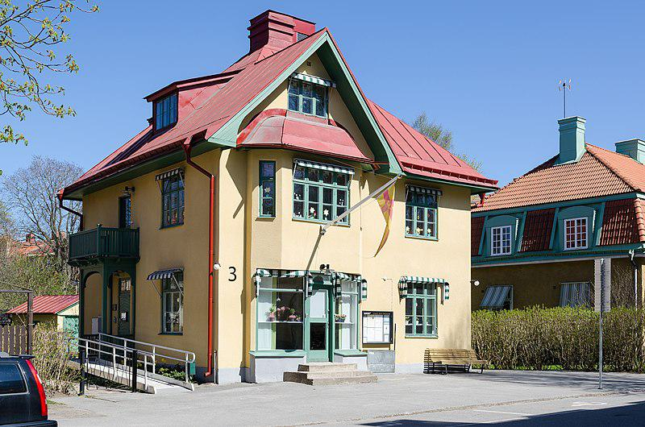

Caption for image source 1: Gamla Enskede 2012b Kyrkvillan (the Church house) at Stora gungans vag 3, in Gamla Enskede. Built 1908, architect Frithiof Svensson. Gamla Enskede is a district of Enskede-Arsta borough, South Stockholm, Sweden. The house belongs to Enskede-Arsta parish..

Example Question - "What pattern is on the window awnings of the Kyrkvillan at Stora Gungan?"

Example Answer - "The window awnings of the Kyrkvillan at Stora Gungan have stripes."

Additional Text Source 1 - Window replaced the Old English eagþyrl, which literally means 'eye-hole,' and 'eagduru' 'eye-door'. Many Germanic languages, however, adopted the Latin word 'fenestra' to describe a window with glass, such as standard Swedish 'fönster', or German 'Fenster'. (from: Window)

Generated Question - Are the window awnings of Kyrkvillan at Stora Gungan similar in pattern to the meaning of the word "window" in Germanic languages?

Generated Answer - No, the awnings have stripes, while the word "window" relates to an eye or opening.

--- Entry for custom_id: d5bbebd60dba11ecb1e81171463288e9 ---

Image Source 1 -



Caption for image source 1: Schokoladen-Kosmee (Cosmos atrosanguineus) 7238.

Example Question - "Do the ends of the Chocolate cosmos's flower petals curl downward or upward?"

Example Answer - "The ends of the Chocolate cosmos's flower petals curl downward."

Additional Text Source 1 - After more prayers, this carpet, along with the cross drawn in lime or flower petals is brought to the grave of the deceased at midnight to be deposited. (from: Santa Cruz Xoxocotlán)

Generated Question - Does the Chocolate cosmos flower's petal shape resemble the curved shape of the lime or flower petal cross used in Santa Cruz Xoxocotlán grave rituals?

Generated Answer - Yes, both have curved shapes with petals or lines curling downward.

--- Entry for custom_id: d5bbec260dba11ecb1e81171463288e9 ---

Image Source 1 -



Caption for image source 1: Joe Mays (American football) Joe Mays, a player on the Denver Broncos American football team..

Example Question - "How many arms does Joe Mays of the Broncos have tattooed?"

Example Answer - "Joe Mays of the Broncos have two arms tattooed."

Additional Text Source 1 - Many popular songs reference Mays. The Treniers recorded the most famous one—"Say Hey (The Willie Mays Song)"—in 1954, with Mays himself participating in the recording. (from: Willie Mays)

Generated Question - Is Joe Mays, the Denver Broncos player, the same person referenced in the song "Say Hey (The Willie Mays Song)"?

Generated Answer - No, Joe Mays is a football player, while the song references Willie Mays, a different person.

--- Entry for custom_id: d5bbecbc0dba11ecb1e81171463288e9 ---

Image Source 1 -

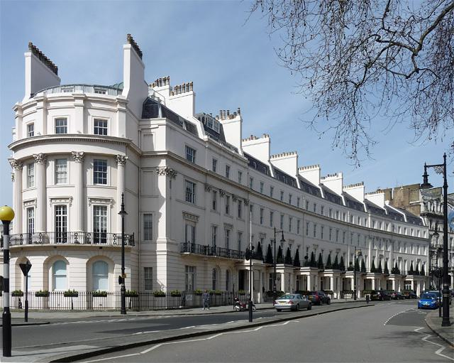

Caption for image source 1: 1–10 Grosvenor Crescent 110 Grosvenor Crescent This is a photo of listed building number 1214153..

Image Source 2 -

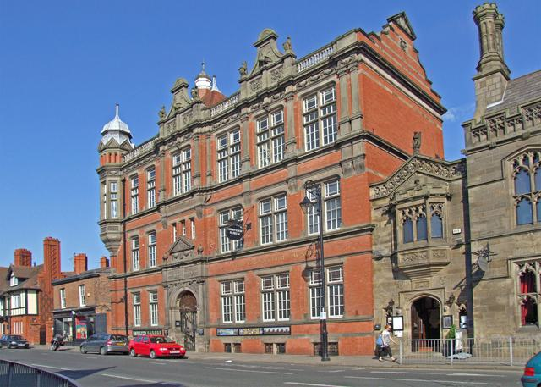

Caption for image source 2: Grosvenor Museum - geograph.org.uk - 1335188 Grosvenor Museum.

Example Question - "Are the walls of both Grosvenor Crescent and Grosvenor Museum curved?"

Example Answer - "The walls of both Grosvenor Crescent and Grosvenor Museum are not curved"

Additional Text Source 1 - The names of the wards were as follows: Albert Park, Charlestown, Crescent, Grosvenor, Hope, Islington, Kersal, Ordsall, Regent, St Matthias's, St Paul's, St Thomas's, Seedley, Trafford, Trinity and Weaste. (from: County Borough of Salford)

Generated Question - Are Grosvenor Crescent and Grosvenor Museum located in the same ward named Grosvenor?

Generated Answer - No, the text does not confirm that either Grosvenor Crescent or Grosvenor Museum is in the Grosvenor ward.

--- Entry for custom_id: d5bbed0c0dba11ecb1e81171463288e9 ---

Image Source 1 -



Caption for image source 1: Pierre Patel, the Elder, Landscape in the Roman Campagna, c.1638-9. Ashmolean Museum.

Example Question - "What color clothing is the person carrying the walking stick wearing in Pierre Patel's painting The Elder, Landscape in the Roman Campagna?"

Example Answer - "The guy carrying the walking stick wears red clothes in Pierre Patel's painting The Elder, Landscape in the Roman Campagna."

Additional Text Source 1 - Goethe in the Roman Campagna is a painting by Johann Heinrich Wilhelm Tischbein, a German Neoclassical painter, depicting Johann Wolfgang von Goethe when the writer was travelling in Italy. Goethe's book on his travels to Italy from 1786–88, called Italian Journey, was published in 1816–17; the book is based on his diaries. (from: Goethe in the Roman Campagna)

Generated Question - How do the landscapes in Pierre Patel's painting and Tischbein's Goethe in the Roman Campagna both reflect the Roman countryside?

Generated Answer - Both paintings depict natural, expansive Roman countryside with ruins and vegetation.